Test Case: tc001_SPX_Dev5_Validar_Campos_Proceso_Nuevo_Articulos_Almacen
Step 1 - Enter username and password and click to button Enter : Credentials Entered
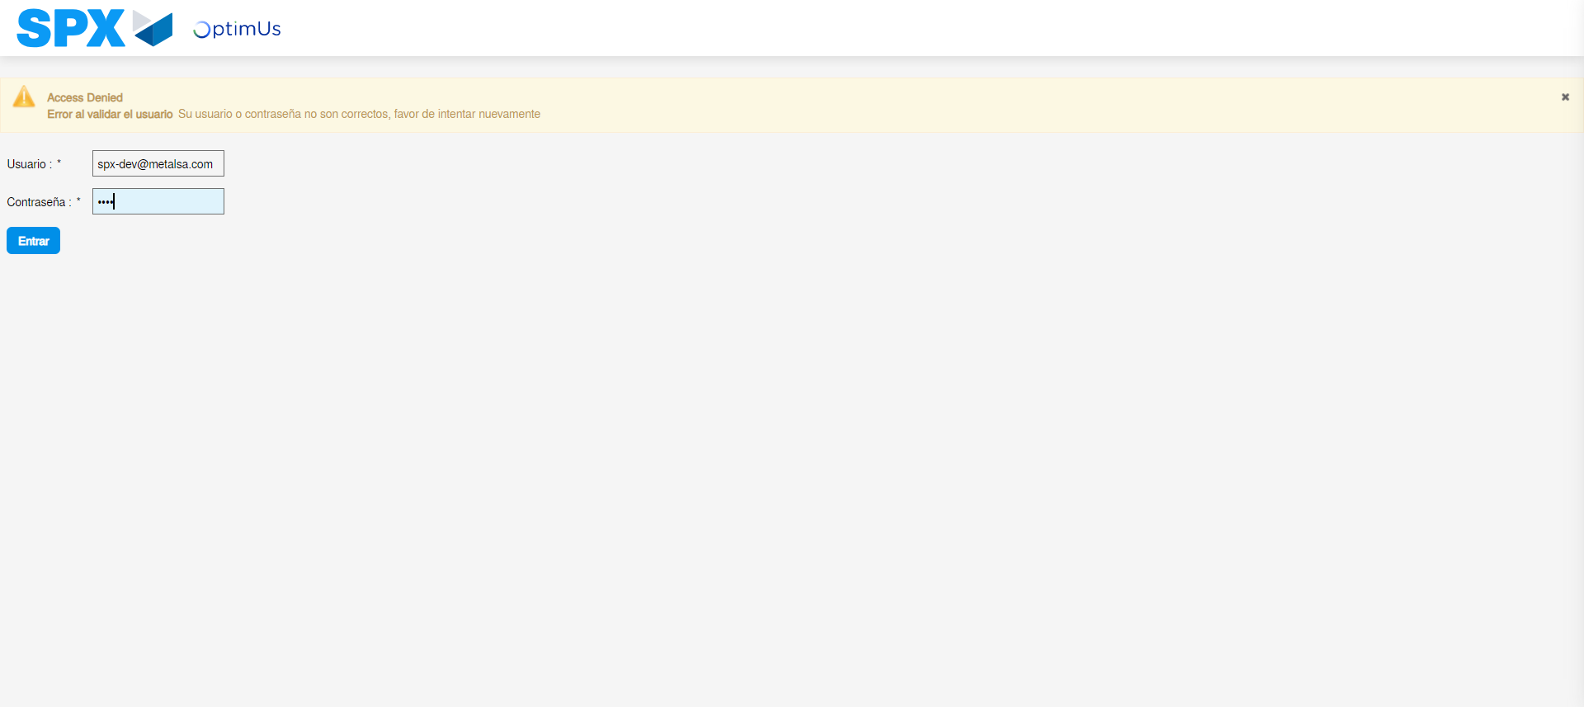Image file-name: QC_Testing-tc001_SPX_Dev5_Validar_Campos_Proceso_Nuevo_Articulos_Almacen-may. 17 2024, 02 26 21 p. m.

Image file-name: QC_Testing-tc001_SPX_Dev5_Validar_Campos_Proceso_Nuevo_Articulos_Almacen-may. 17 2024, 02 26 22 p. m.

Step 2 - Select to UEN and Access to Articulos por Procesar: UEN Correctly selected and Correct access
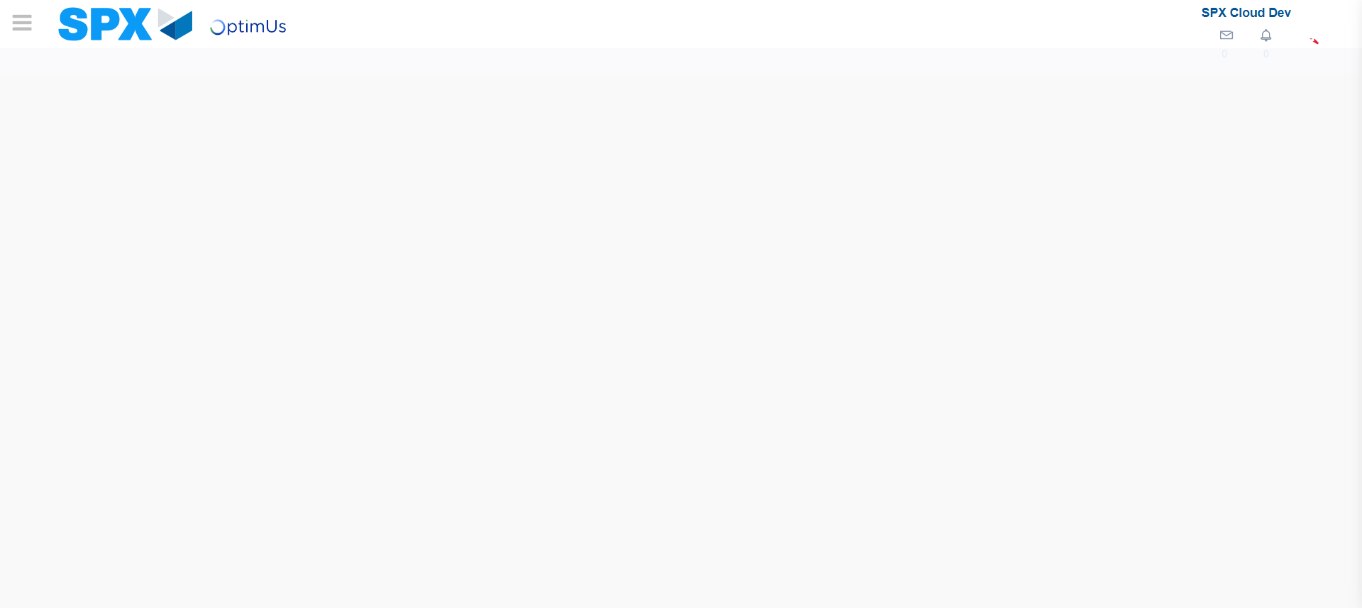Image file-name: QC_Testing-tc001_SPX_Dev5_Validar_Campos_Proceso_Nuevo_Articulos_Almacen-may. 17 2024, 02 26 27 p. m.

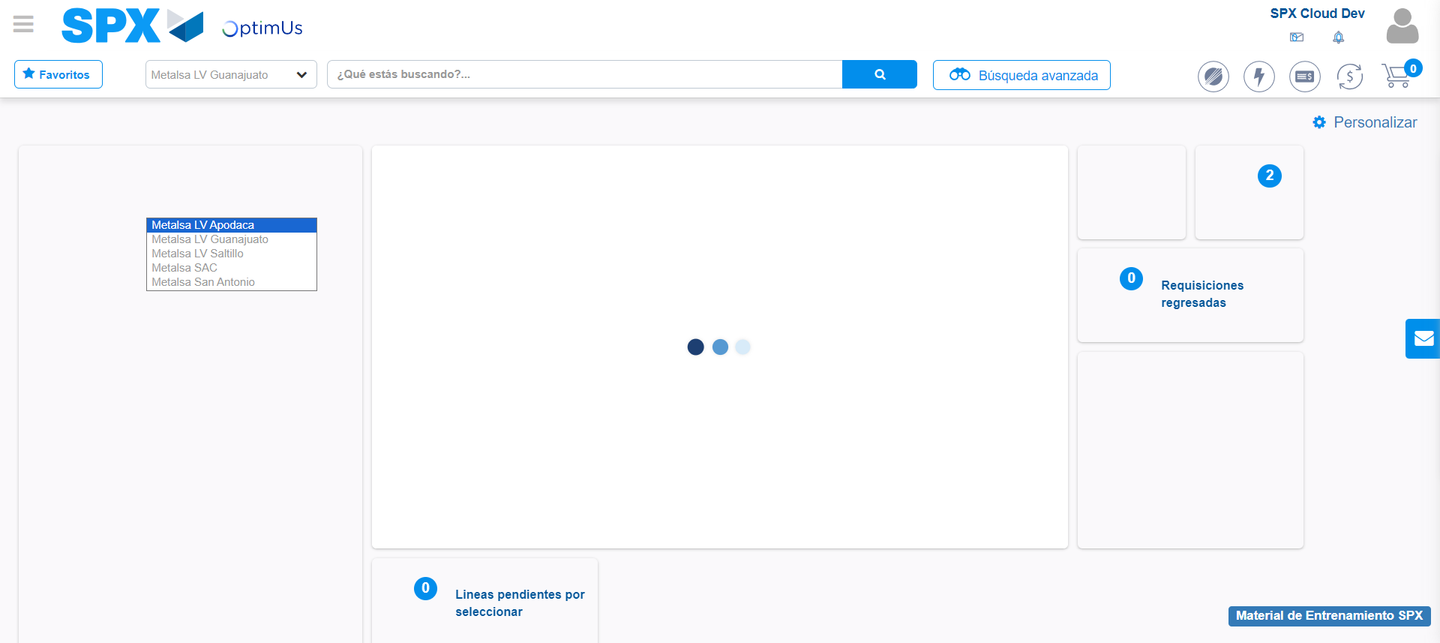Image file-name: QC_Testing-tc001_SPX_Dev5_Validar_Campos_Proceso_Nuevo_Articulos_Almacen-may. 17 2024, 02 26 28 p. m.

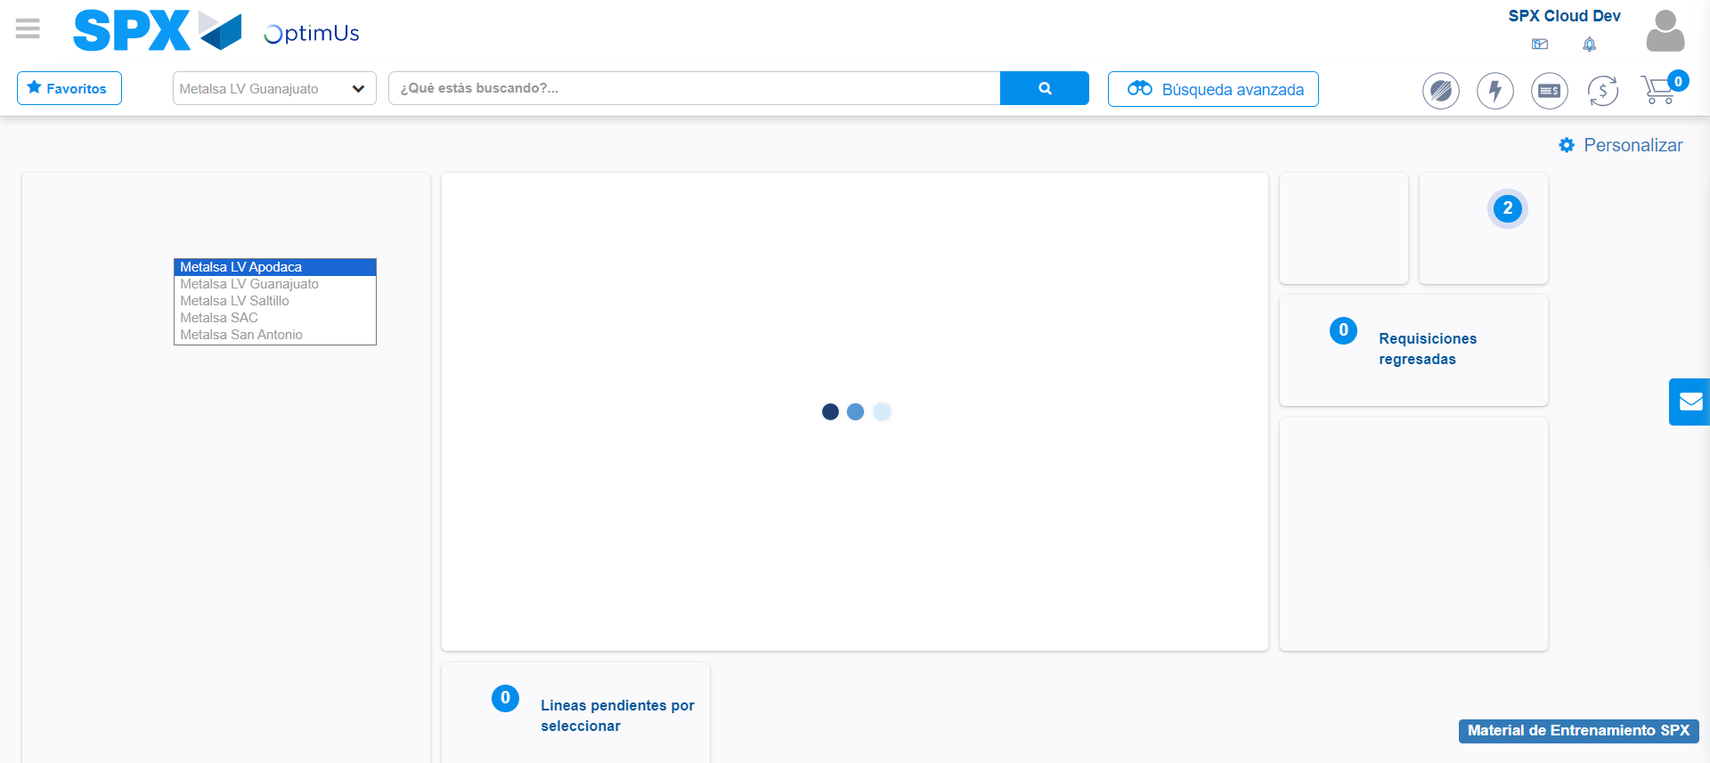Image file-name: QC_Testing-tc001_SPX_Dev5_Validar_Campos_Proceso_Nuevo_Articulos_Almacen-may. 17 2024, 02 26 29 p. m.

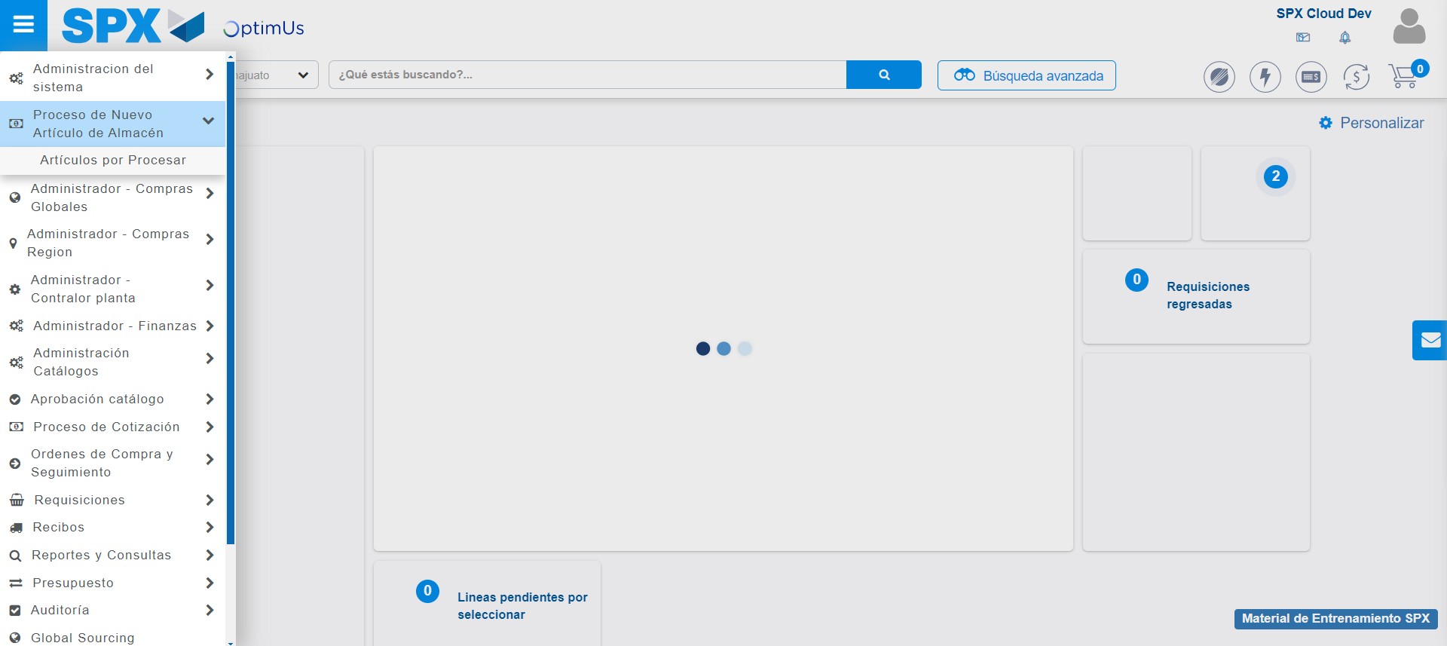Image file-name: QC_Testing-tc001_SPX_Dev5_Validar_Campos_Proceso_Nuevo_Articulos_Almacen-may. 17 2024, 02 26 30 p. m.

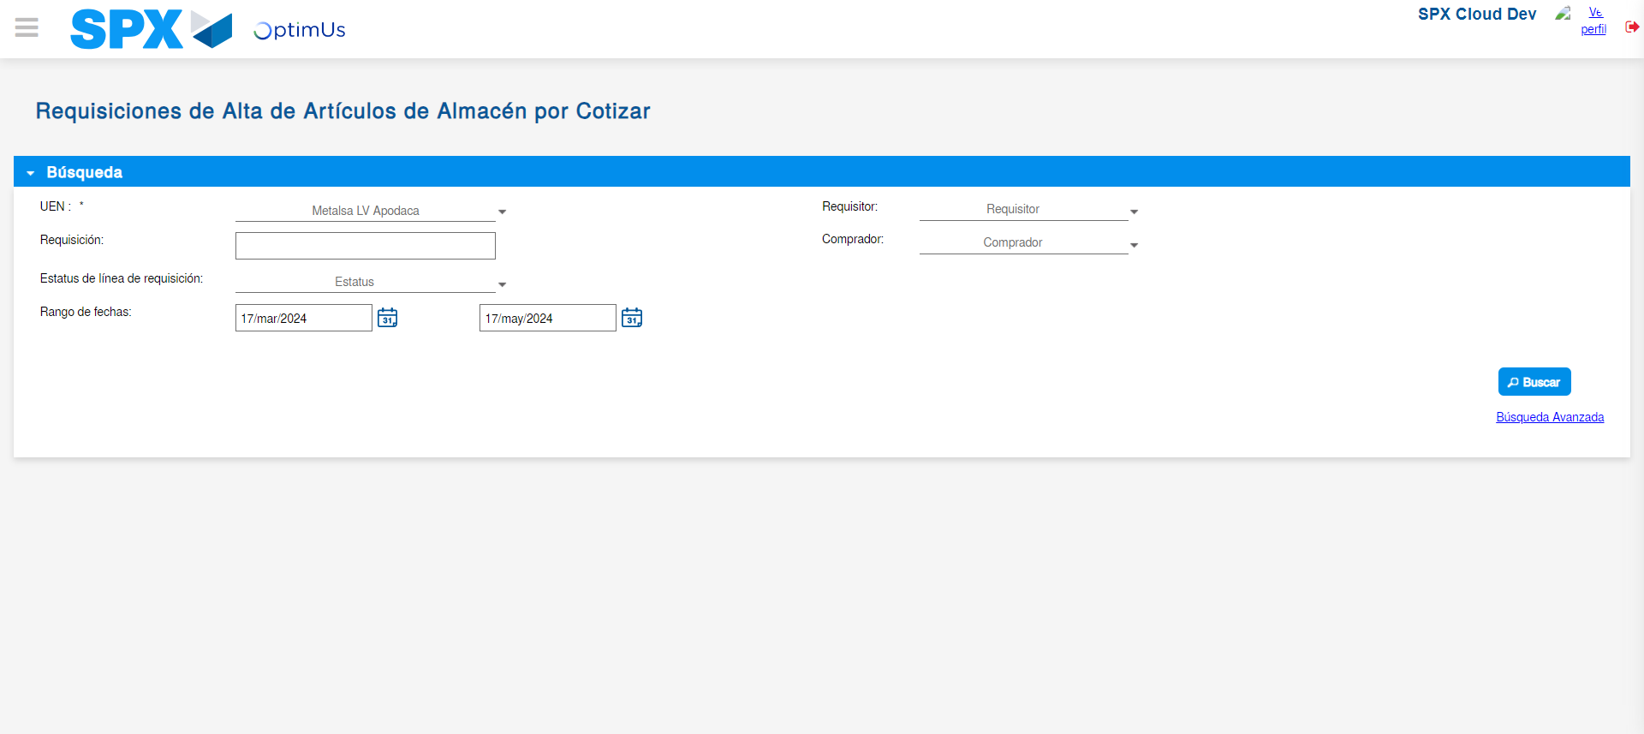Image file-name: QC_Testing-tc001_SPX_Dev5_Validar_Campos_Proceso_Nuevo_Articulos_Almacen-may. 17 2024, 02 26 34 p. m.

Image file-name: QC_Testing-tc001_SPX_Dev5_Validar_Campos_Proceso_Nuevo_Articulos_Almacen-may. 17 2024, 02 26 35 p. m.

Step 3 - Validate search fields: Validated fields
Image file-name: QC_Testing-tc001_SPX_Dev5_Validar_Campos_Proceso_Nuevo_Articulos_Almacen-may. 17 2024, 02 26 35 p. m.

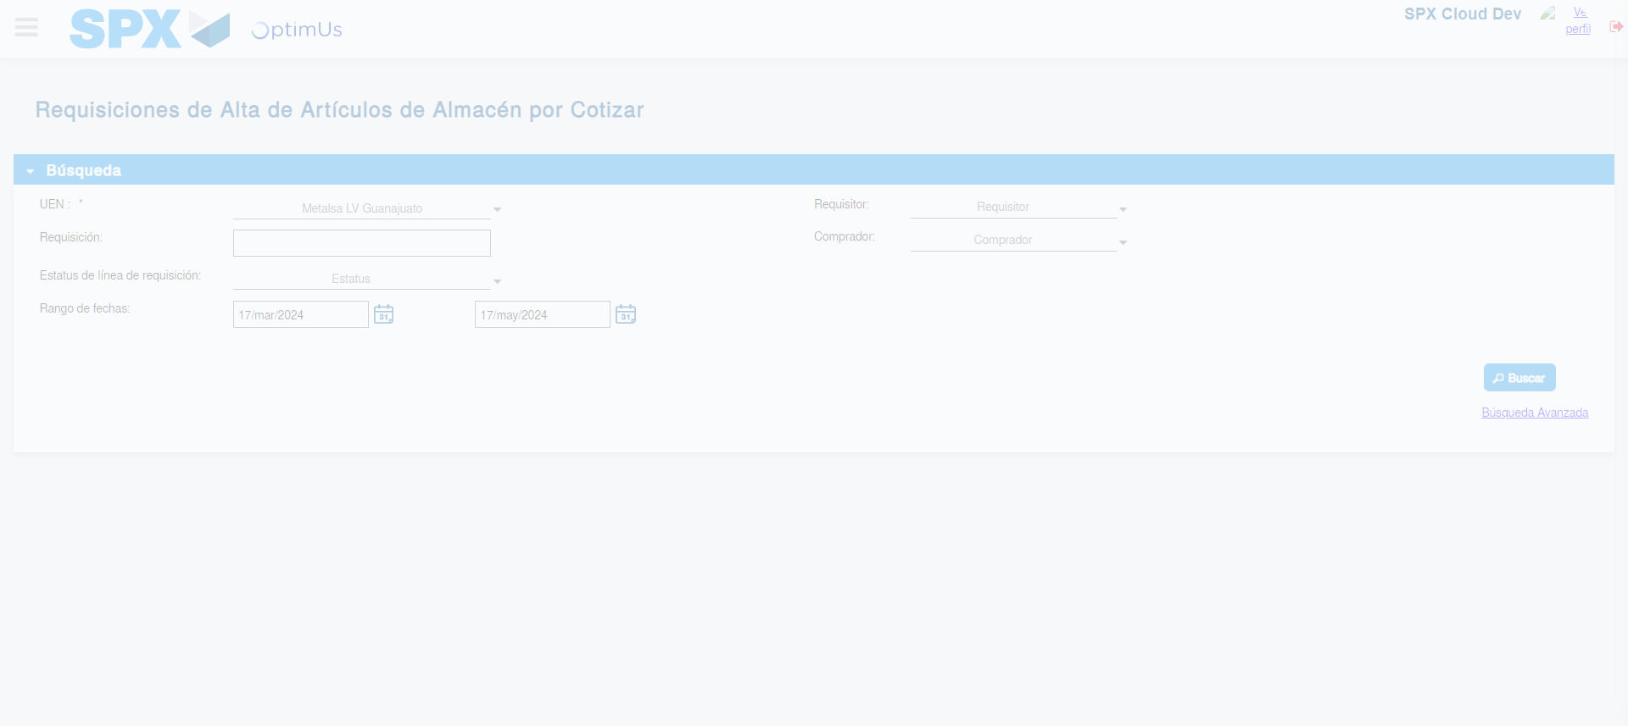Image file-name: QC_Testing-tc001_SPX_Dev5_Validar_Campos_Proceso_Nuevo_Articulos_Almacen-may. 17 2024, 02 26 36 p. m.

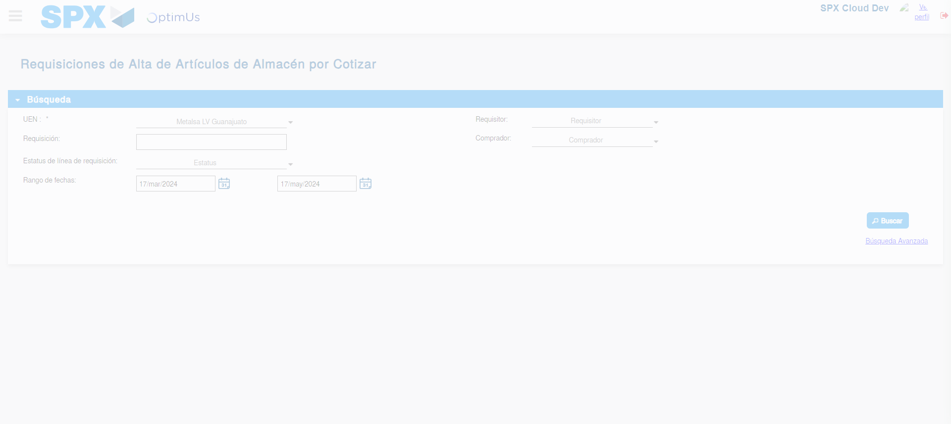Image file-name: QC_Testing-tc001_SPX_Dev5_Validar_Campos_Proceso_Nuevo_Articulos_Almacen-may. 17 2024, 02 26 40 p. m.

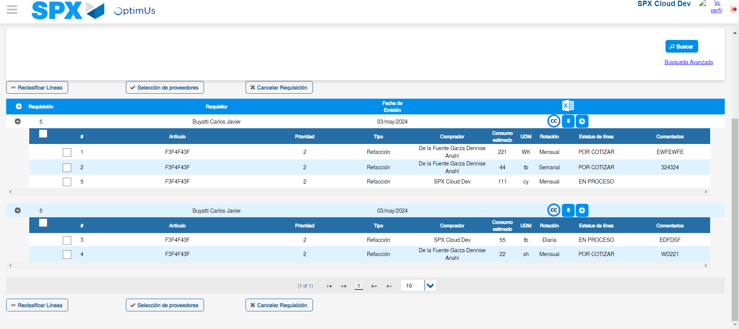Image file-name: QC_Testing-tc001_SPX_Dev5_Validar_Campos_Proceso_Nuevo_Articulos_Almacen-may. 17 2024, 02 26 44 p. m.

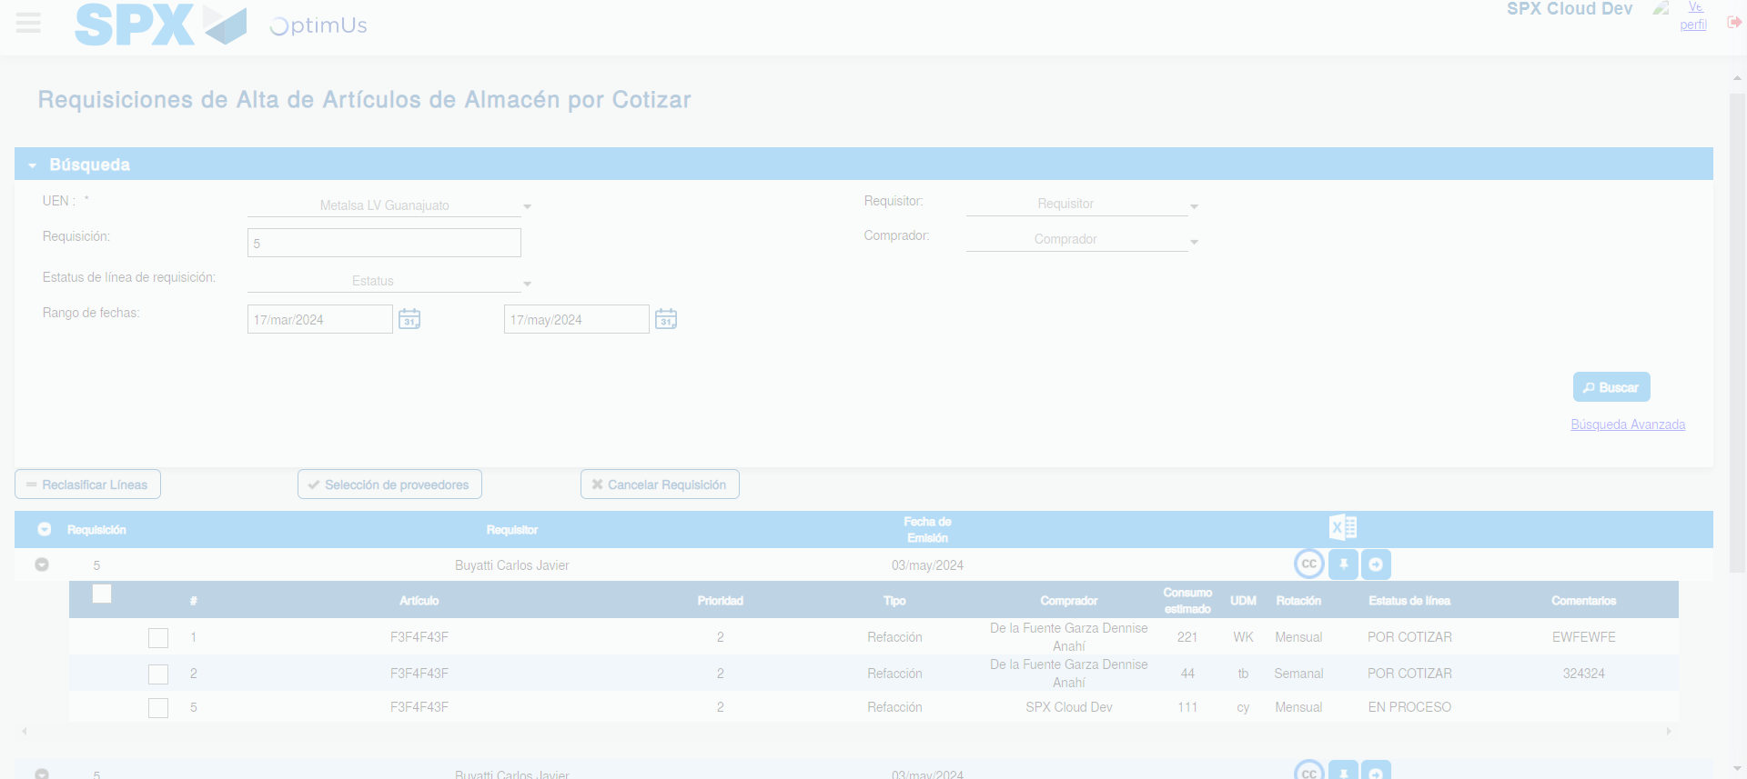Image file-name: QC_Testing-tc001_SPX_Dev5_Validar_Campos_Proceso_Nuevo_Articulos_Almacen-may. 17 2024, 02 26 45 p. m.

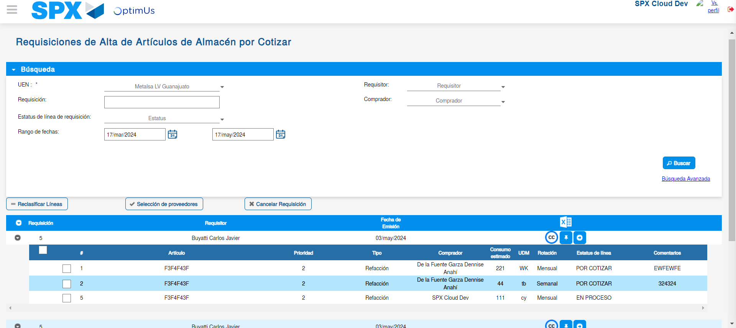Image file-name: QC_Testing-tc001_SPX_Dev5_Validar_Campos_Proceso_Nuevo_Articulos_Almacen-may. 17 2024, 02 26 49 p. m.

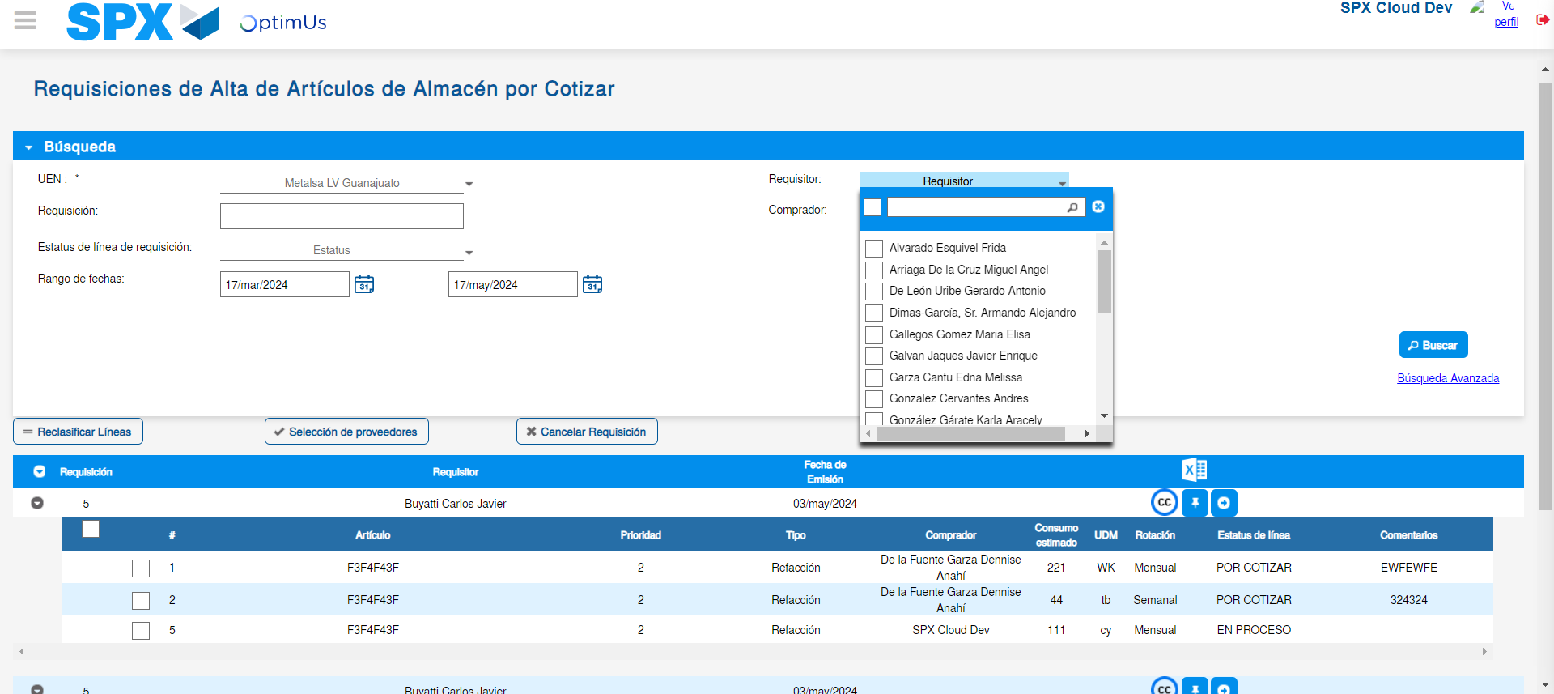Image file-name: QC_Testing-tc001_SPX_Dev5_Validar_Campos_Proceso_Nuevo_Articulos_Almacen-may. 17 2024, 02 26 50 p. m.

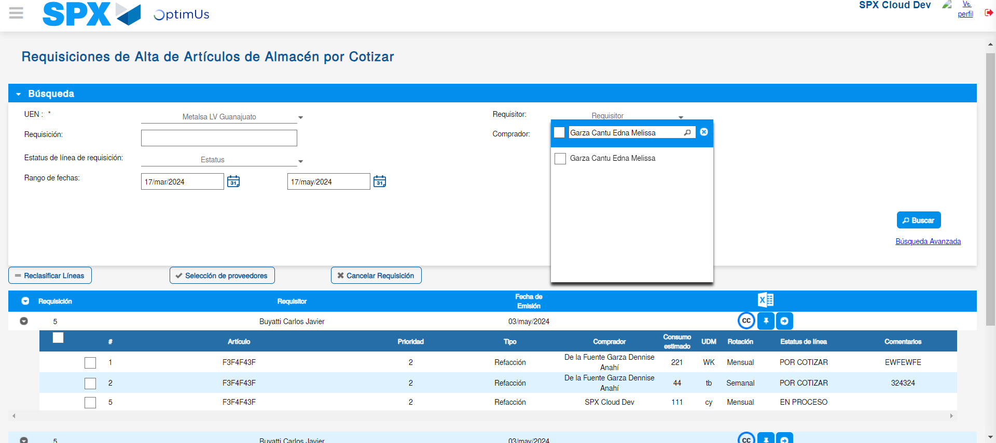Image file-name: QC_Testing-tc001_SPX_Dev5_Validar_Campos_Proceso_Nuevo_Articulos_Almacen-may. 17 2024, 02 26 51 p. m.

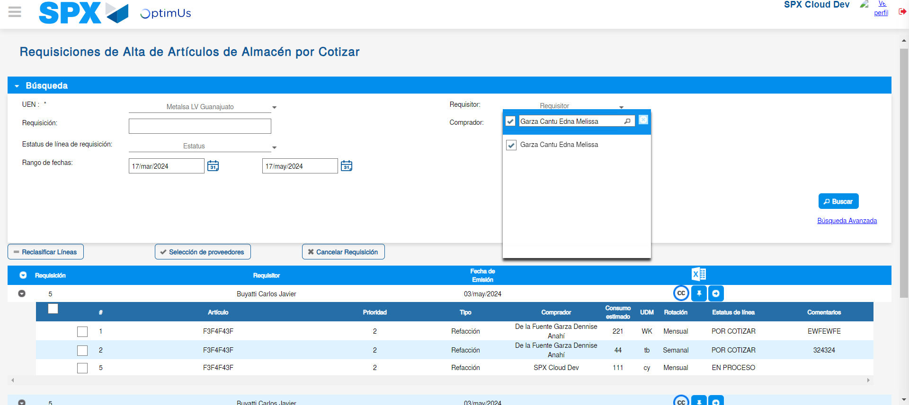Image file-name: QC_Testing-tc001_SPX_Dev5_Validar_Campos_Proceso_Nuevo_Articulos_Almacen-may. 17 2024, 02 26 52 p. m.

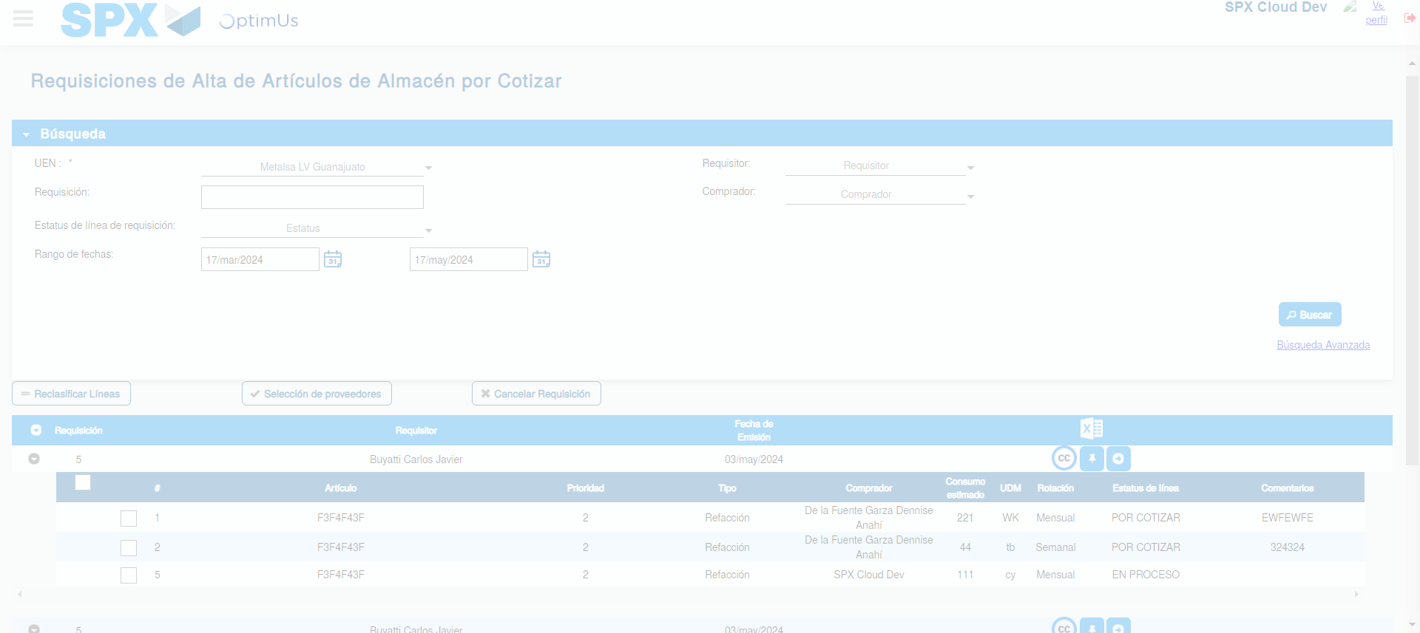Image file-name: QC_Testing-tc001_SPX_Dev5_Validar_Campos_Proceso_Nuevo_Articulos_Almacen-may. 17 2024, 02 26 55 p. m.

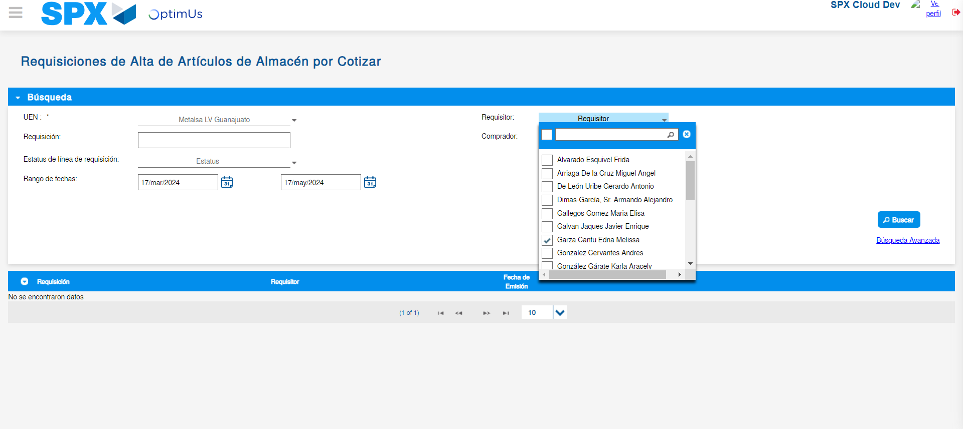Image file-name: QC_Testing-tc001_SPX_Dev5_Validar_Campos_Proceso_Nuevo_Articulos_Almacen-may. 17 2024, 02 26 59 p. m.

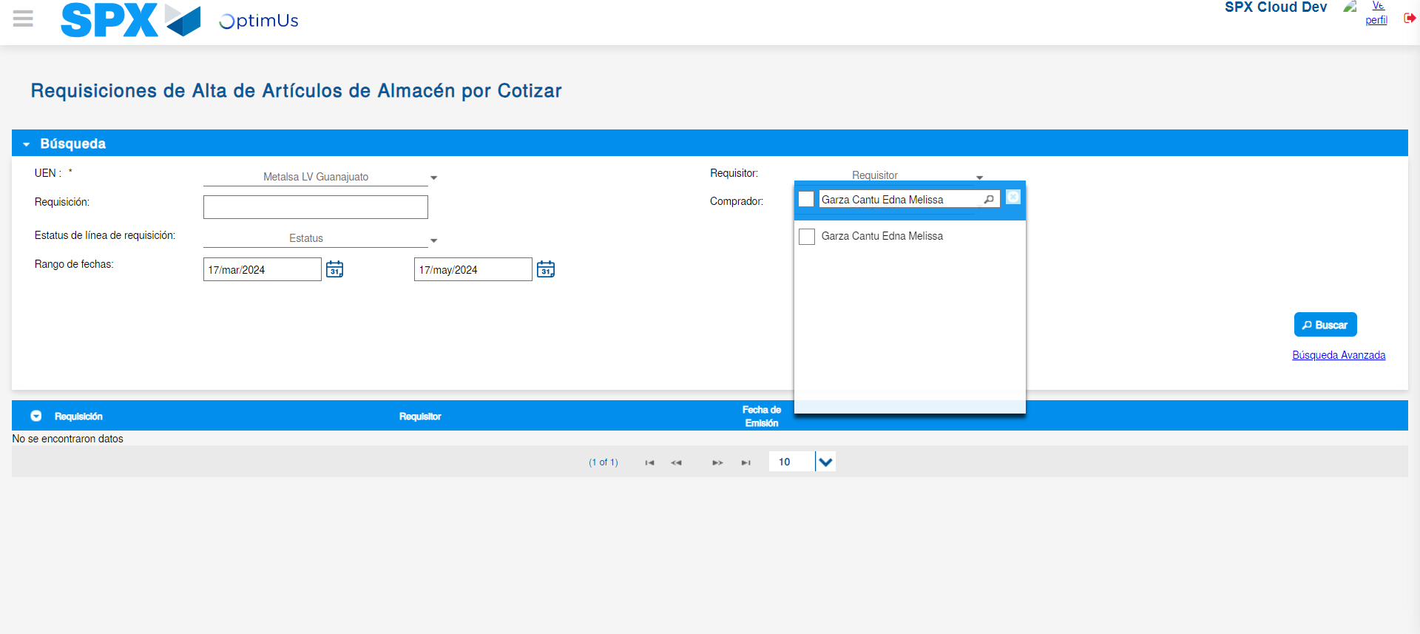Image file-name: QC_Testing-tc001_SPX_Dev5_Validar_Campos_Proceso_Nuevo_Articulos_Almacen-may. 17 2024, 02 27 00 p. m.

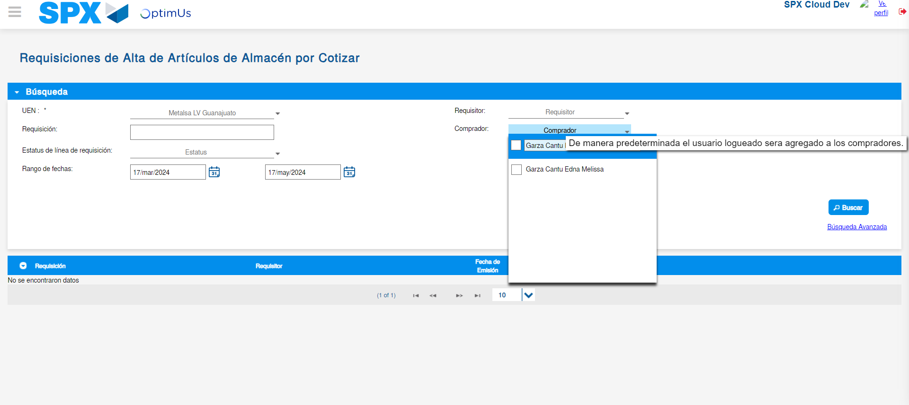Image file-name: QC_Testing-tc001_SPX_Dev5_Validar_Campos_Proceso_Nuevo_Articulos_Almacen-may. 17 2024, 02 27 04 p. m.

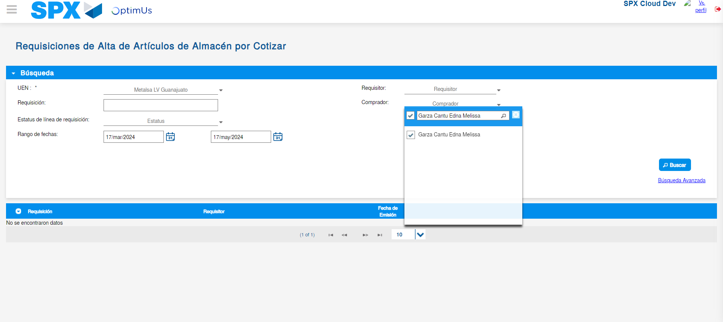Image file-name: QC_Testing-tc001_SPX_Dev5_Validar_Campos_Proceso_Nuevo_Articulos_Almacen-may. 17 2024, 02 27 05 p. m.

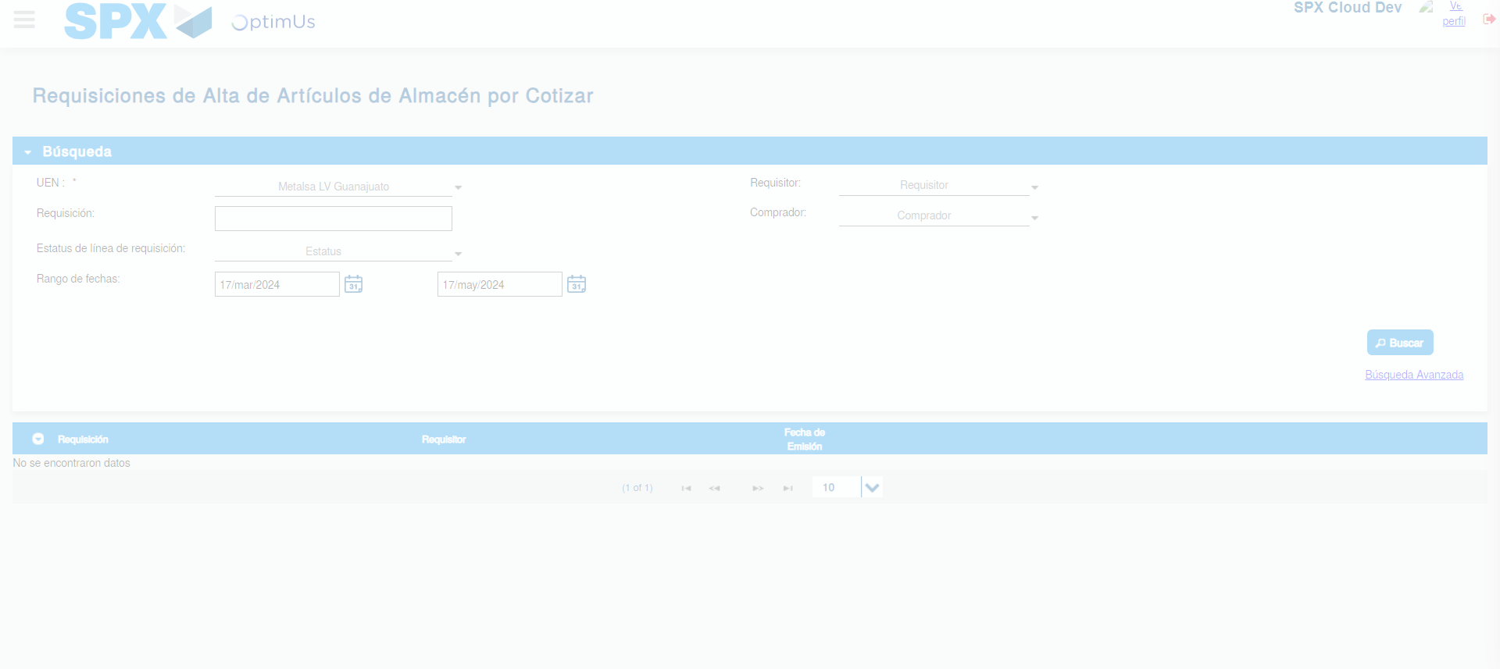Image file-name: QC_Testing-tc001_SPX_Dev5_Validar_Campos_Proceso_Nuevo_Articulos_Almacen-may. 17 2024, 02 27 08 p. m.

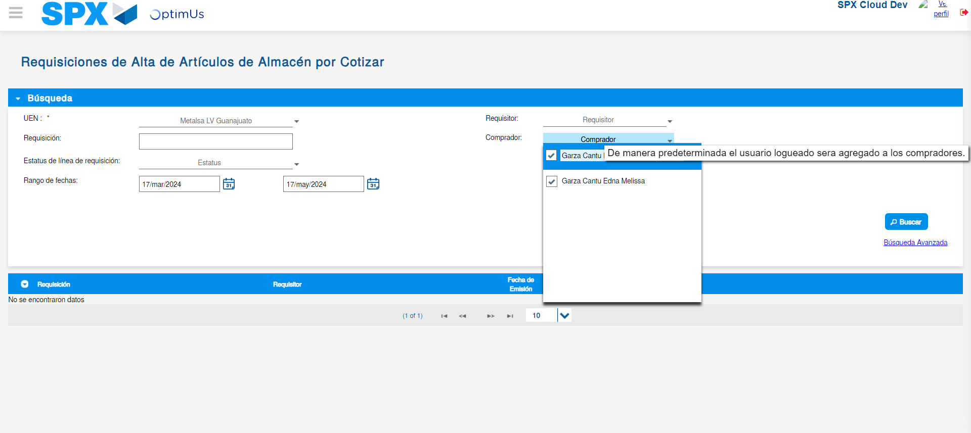Image file-name: QC_Testing-tc001_SPX_Dev5_Validar_Campos_Proceso_Nuevo_Articulos_Almacen-may. 17 2024, 02 27 12 p. m.

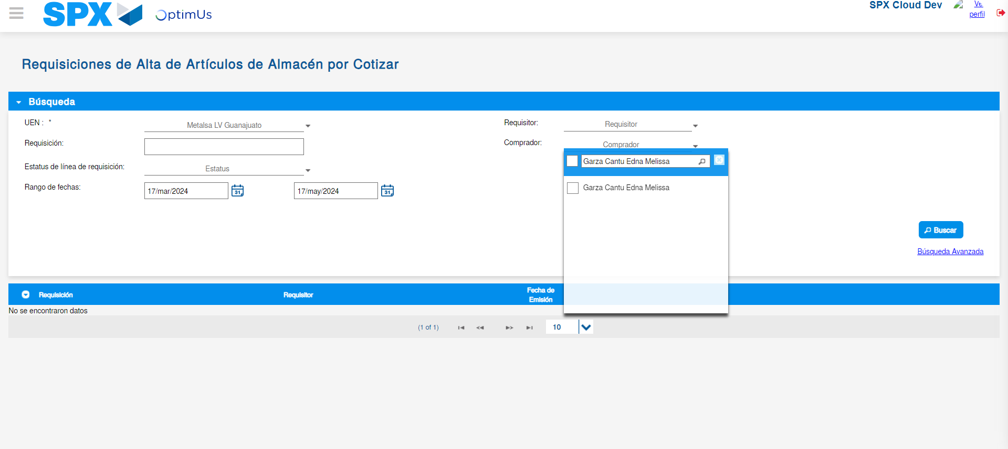Image file-name: QC_Testing-tc001_SPX_Dev5_Validar_Campos_Proceso_Nuevo_Articulos_Almacen-may. 17 2024, 02 27 13 p. m.

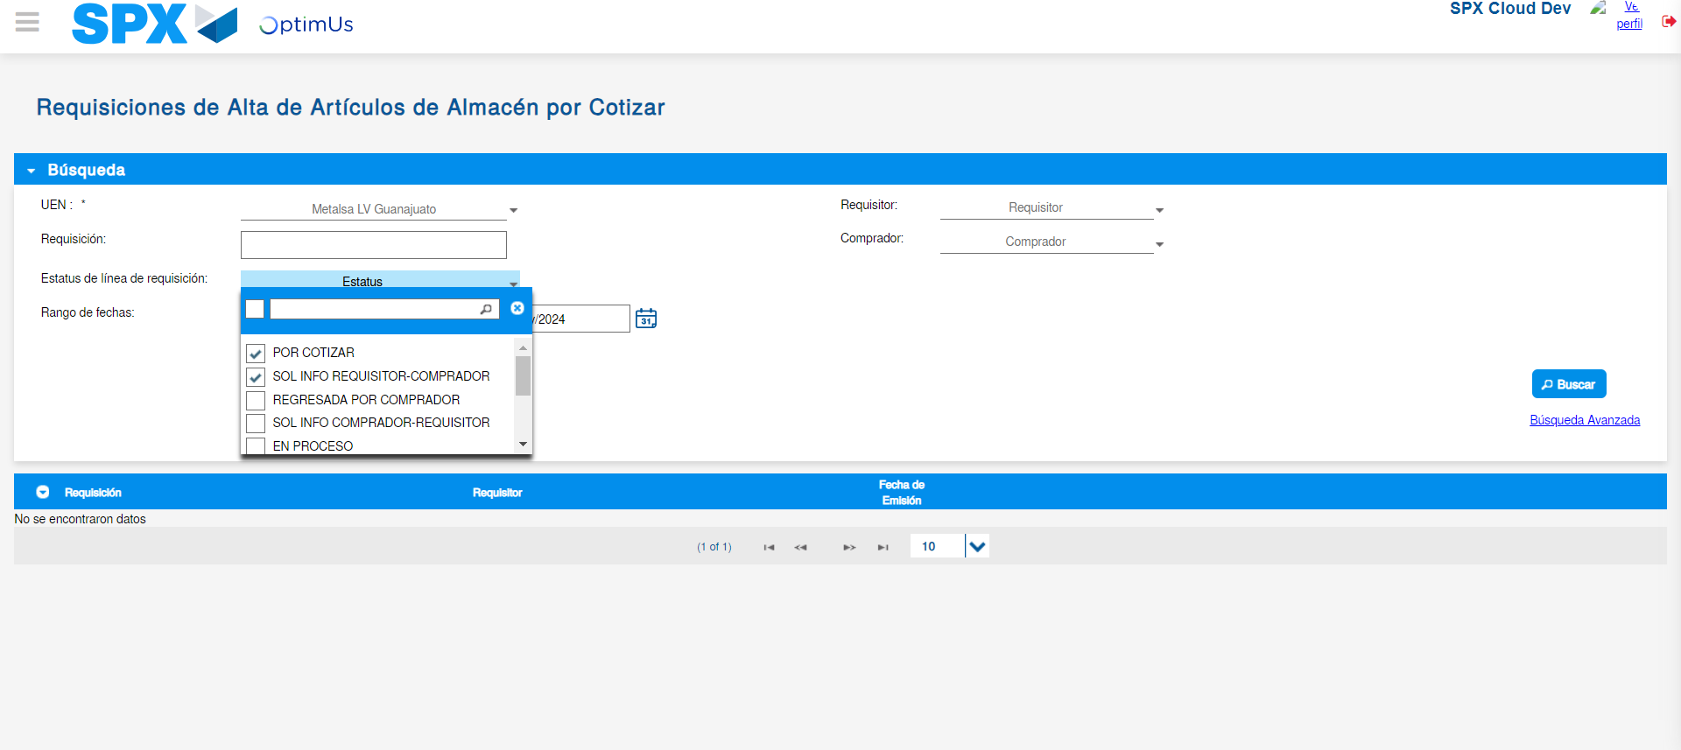Image file-name: QC_Testing-tc001_SPX_Dev5_Validar_Campos_Proceso_Nuevo_Articulos_Almacen-may. 17 2024, 02 27 16 p. m.

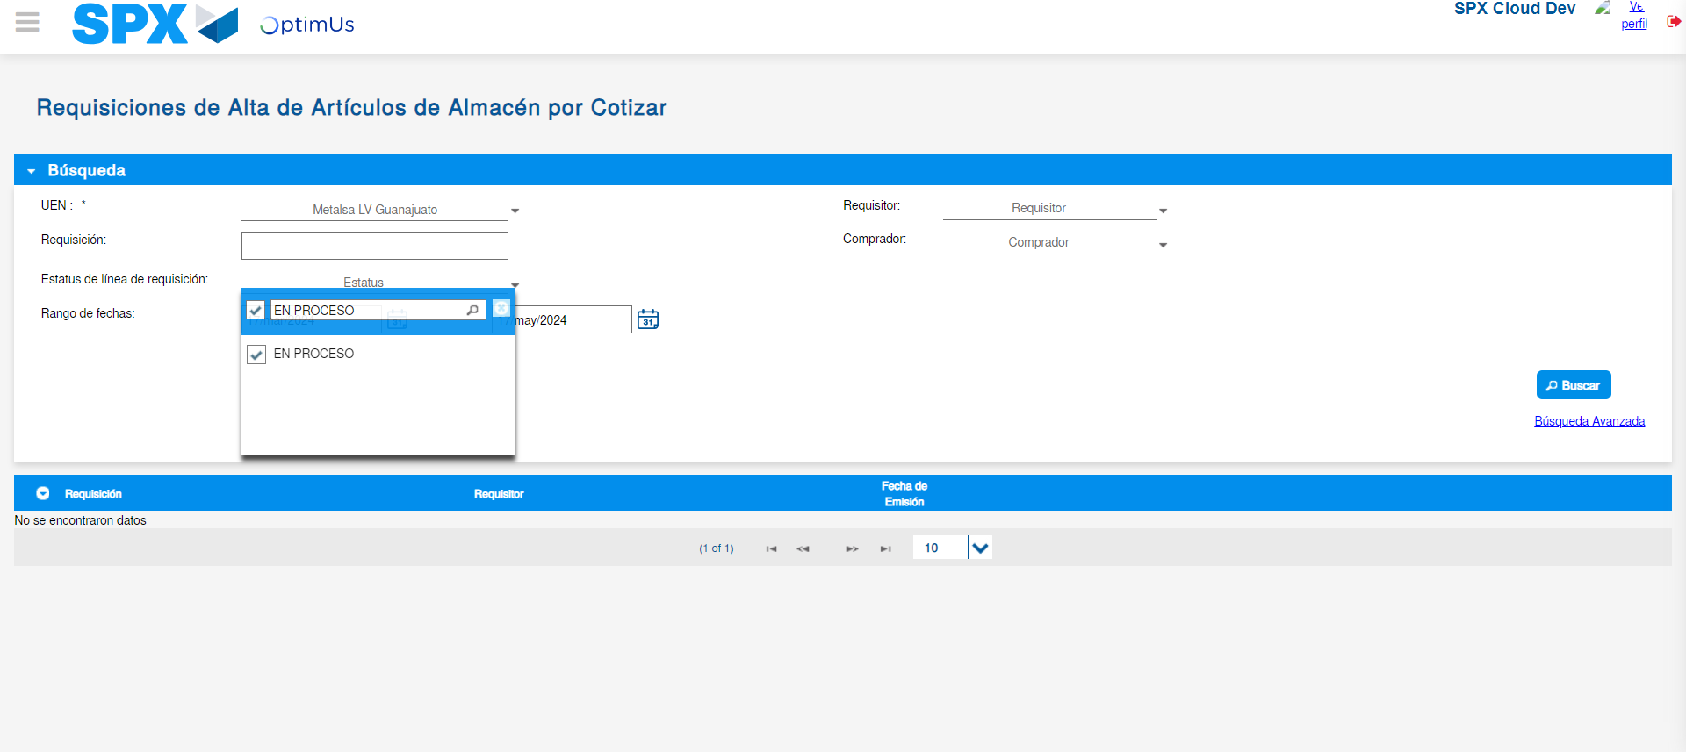Image file-name: QC_Testing-tc001_SPX_Dev5_Validar_Campos_Proceso_Nuevo_Articulos_Almacen-may. 17 2024, 02 27 17 p. m.

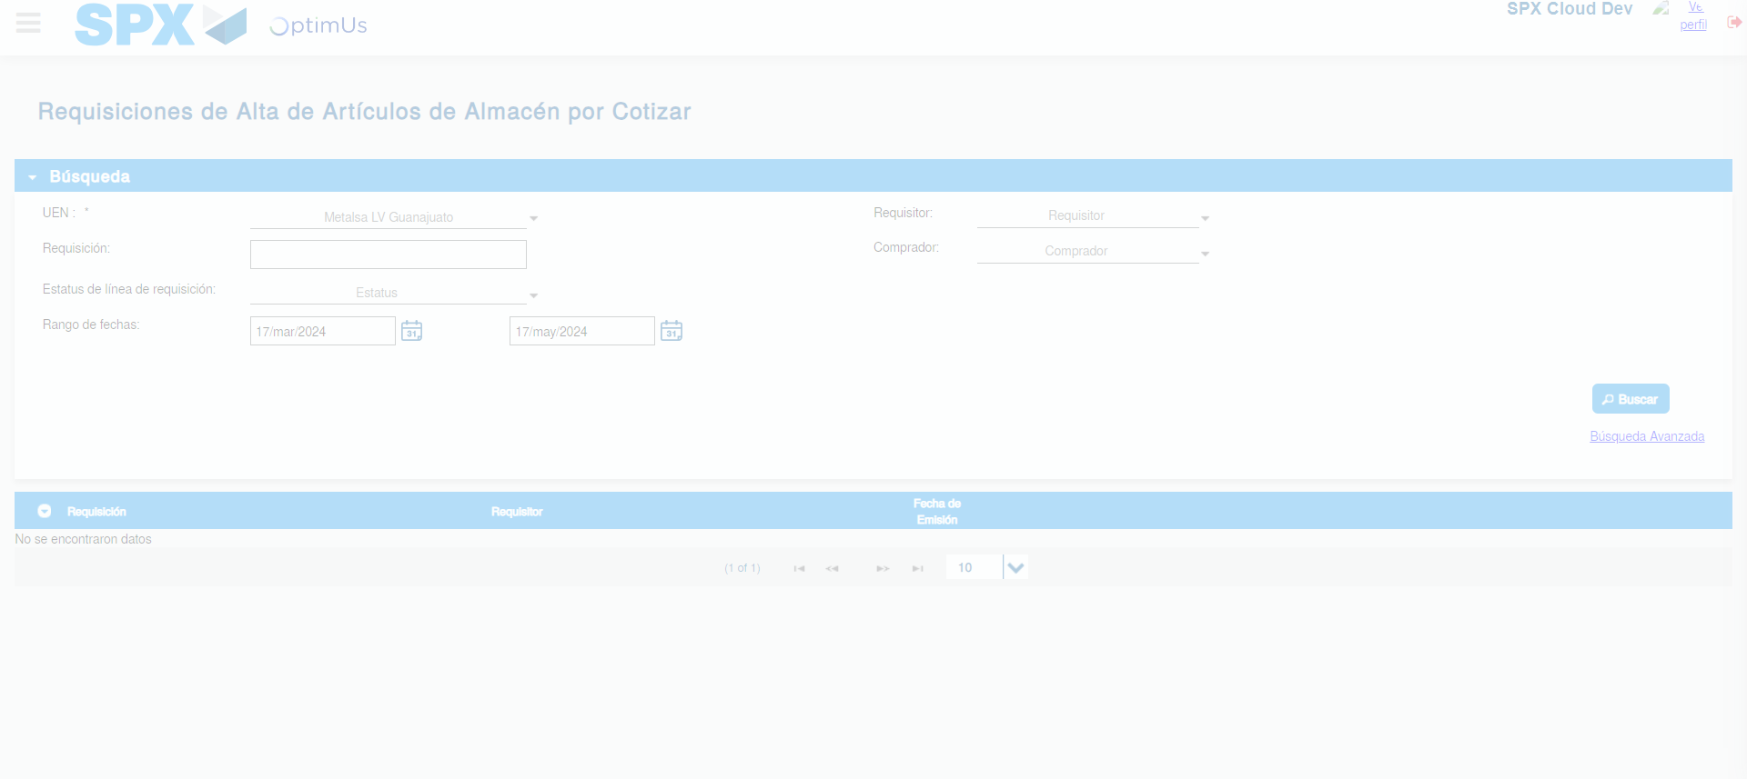Image file-name: QC_Testing-tc001_SPX_Dev5_Validar_Campos_Proceso_Nuevo_Articulos_Almacen-may. 17 2024, 02 27 21 p. m.

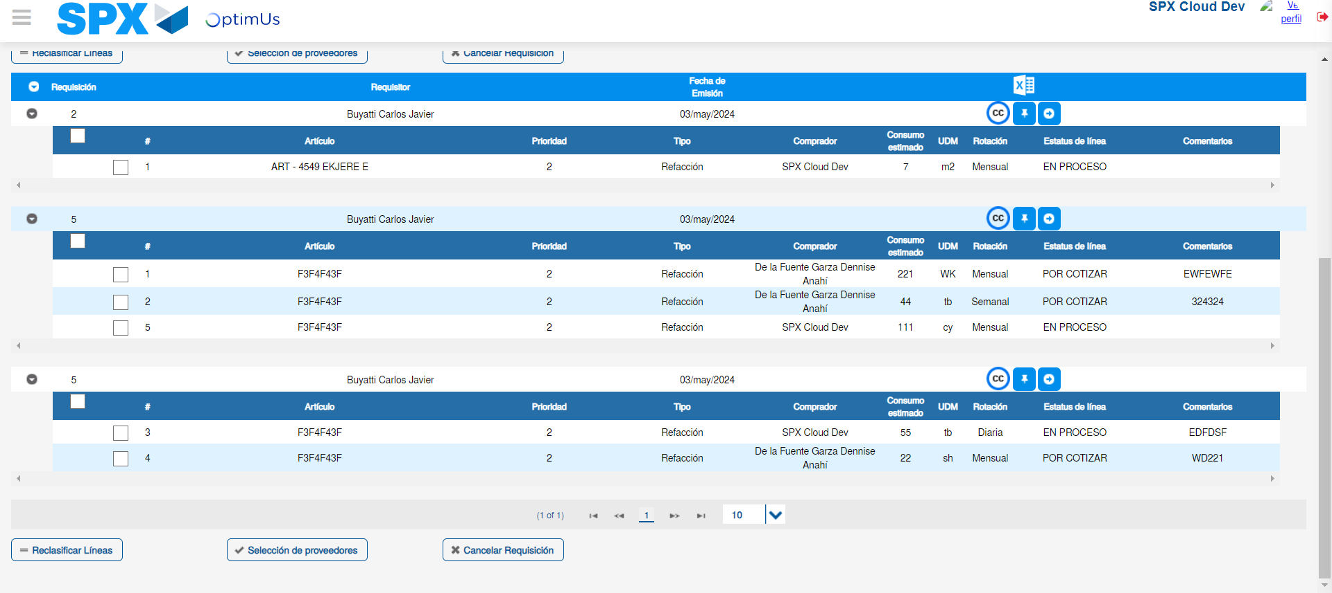Image file-name: QC_Testing-tc001_SPX_Dev5_Validar_Campos_Proceso_Nuevo_Articulos_Almacen-may. 17 2024, 02 27 24 p. m.

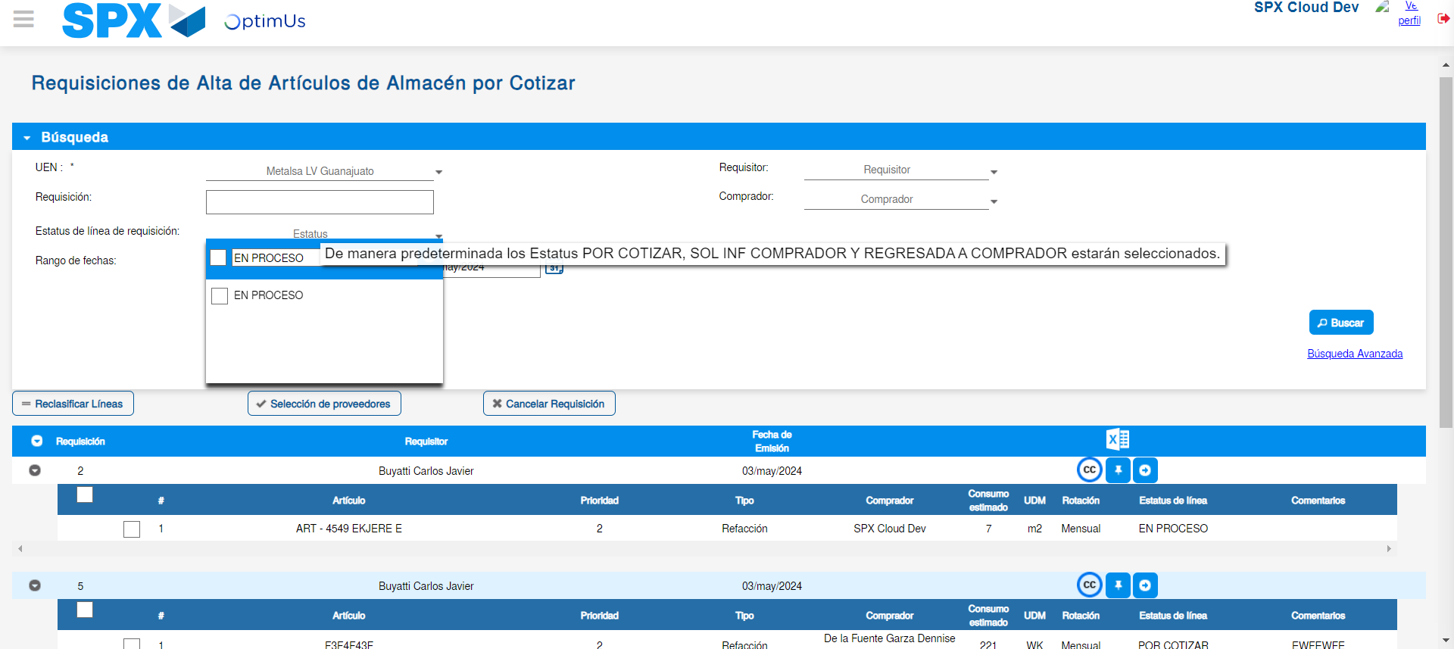Image file-name: QC_Testing-tc001_SPX_Dev5_Validar_Campos_Proceso_Nuevo_Articulos_Almacen-may. 17 2024, 02 27 25 p. m.

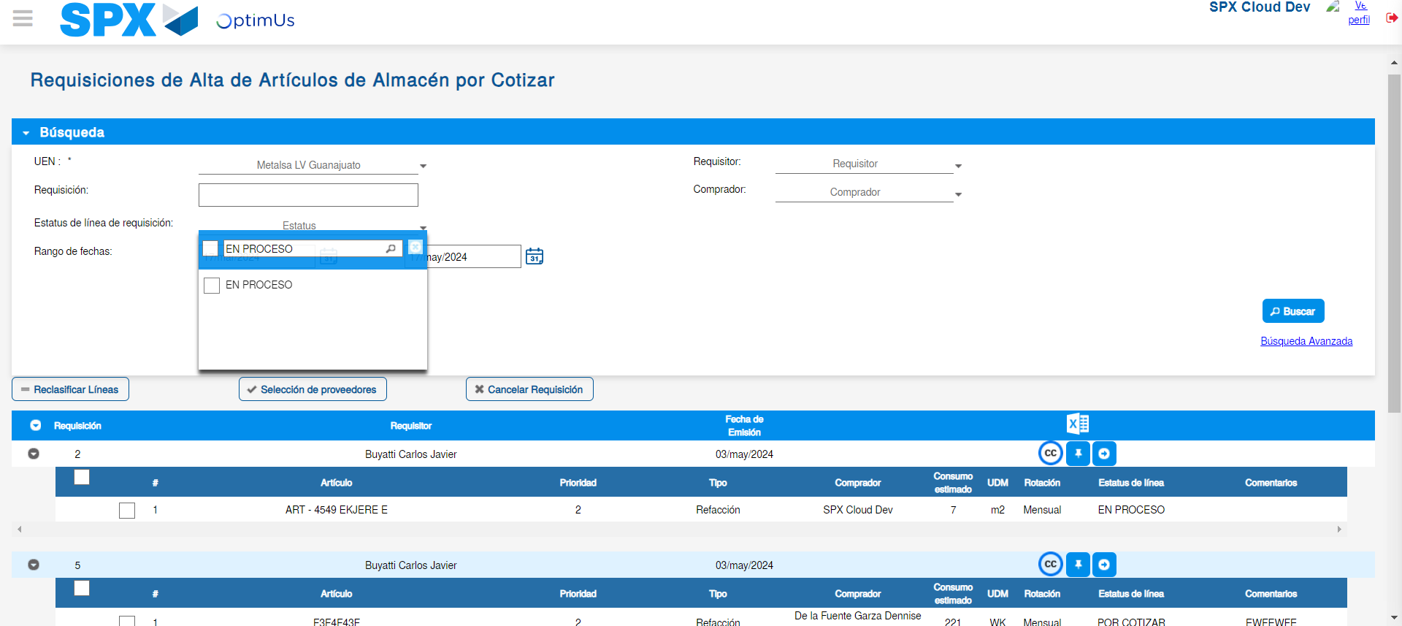Image file-name: QC_Testing-tc001_SPX_Dev5_Validar_Campos_Proceso_Nuevo_Articulos_Almacen-may. 17 2024, 02 27 26 p. m.

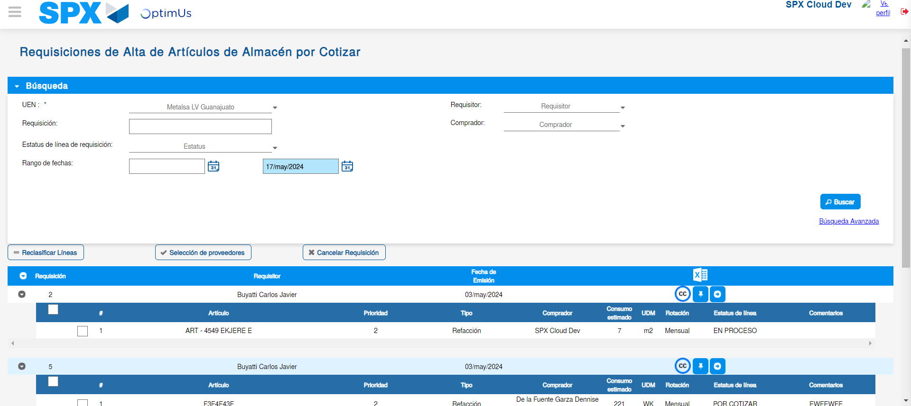Image file-name: QC_Testing-tc001_SPX_Dev5_Validar_Campos_Proceso_Nuevo_Articulos_Almacen-may. 17 2024, 02 27 29 p. m.

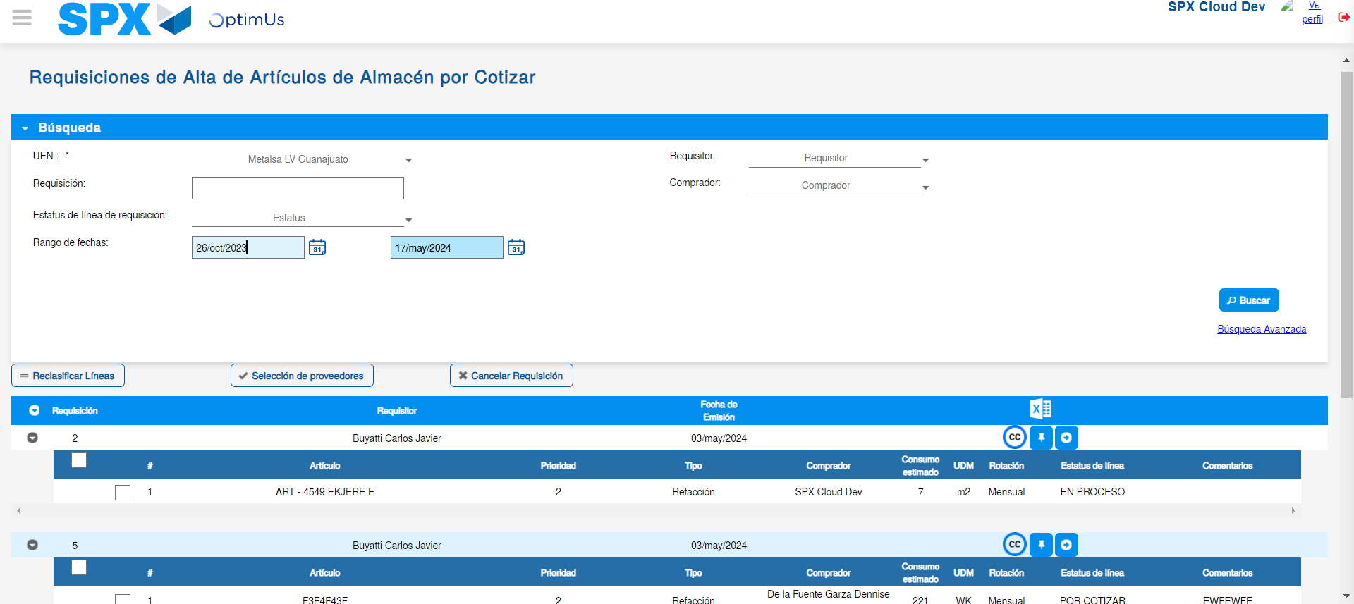Image file-name: QC_Testing-tc001_SPX_Dev5_Validar_Campos_Proceso_Nuevo_Articulos_Almacen-may. 17 2024, 02 27 30 p. m.

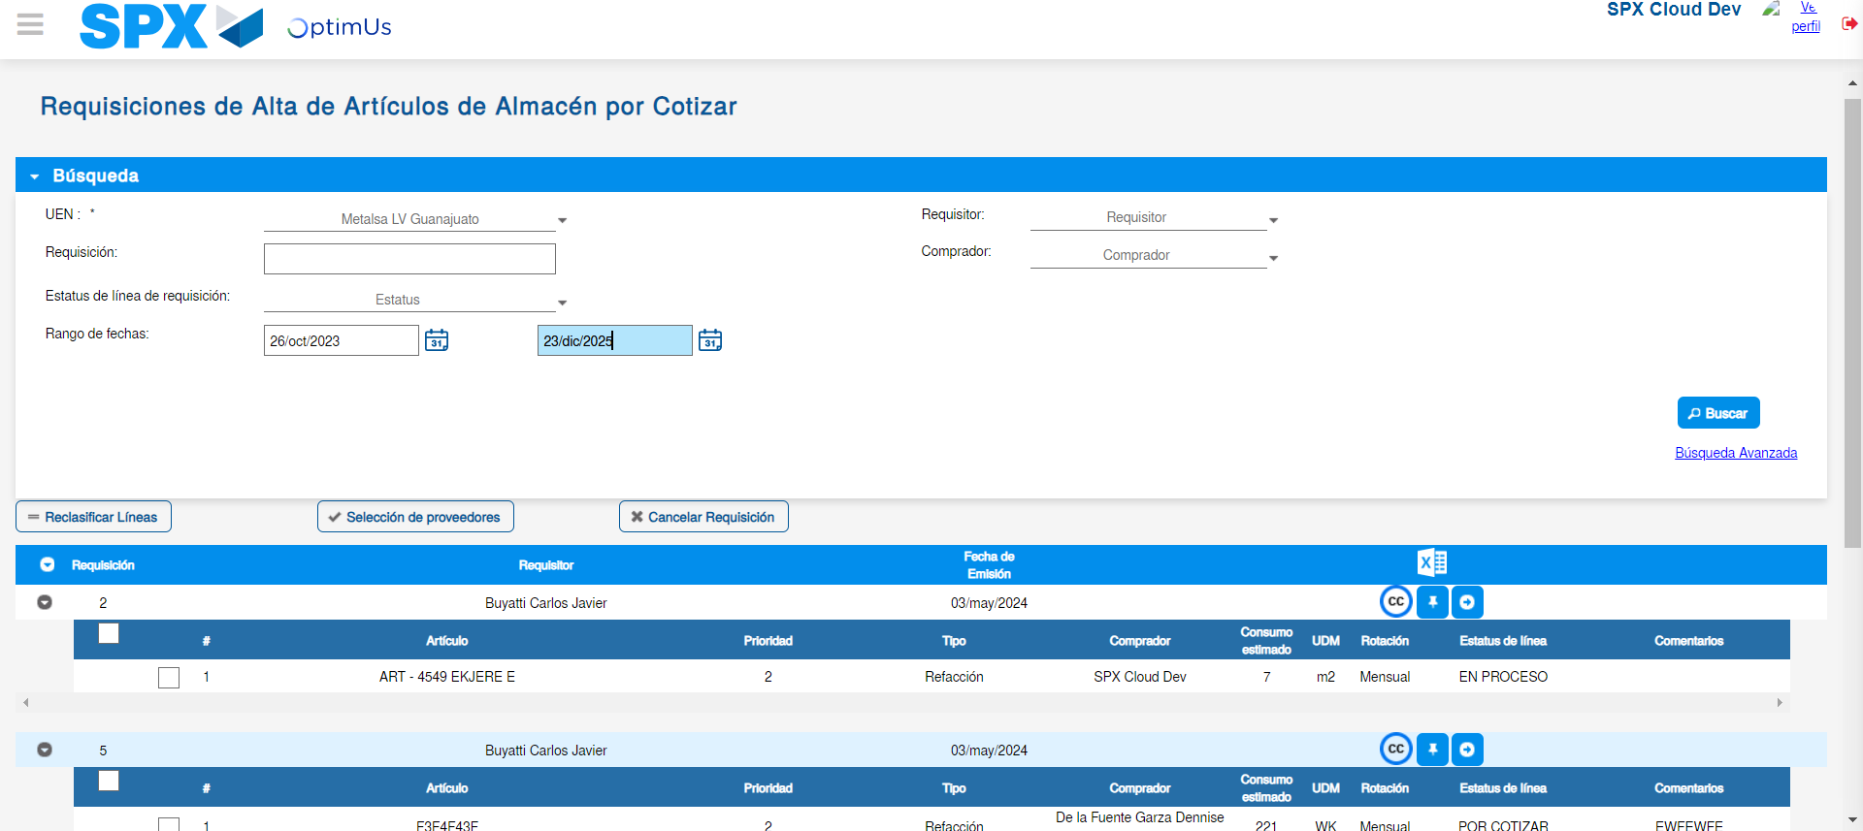Image file-name: QC_Testing-tc001_SPX_Dev5_Validar_Campos_Proceso_Nuevo_Articulos_Almacen-may. 17 2024, 02 27 33 p. m.

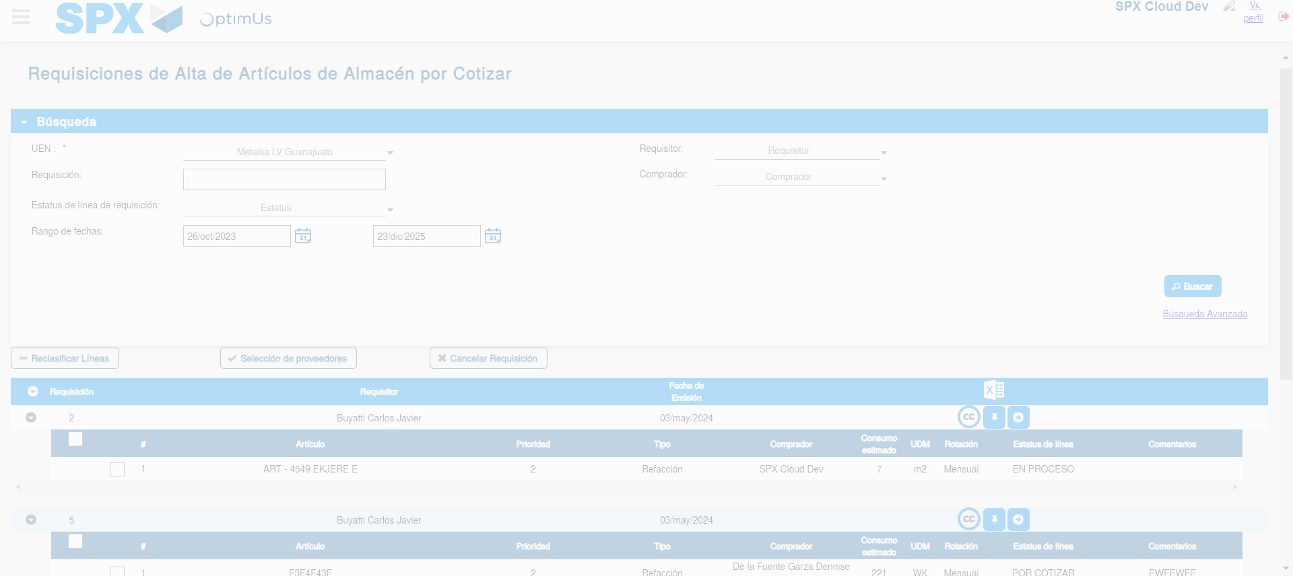Image file-name: QC_Testing-tc001_SPX_Dev5_Validar_Campos_Proceso_Nuevo_Articulos_Almacen-may. 17 2024, 02 27 37 p. m.

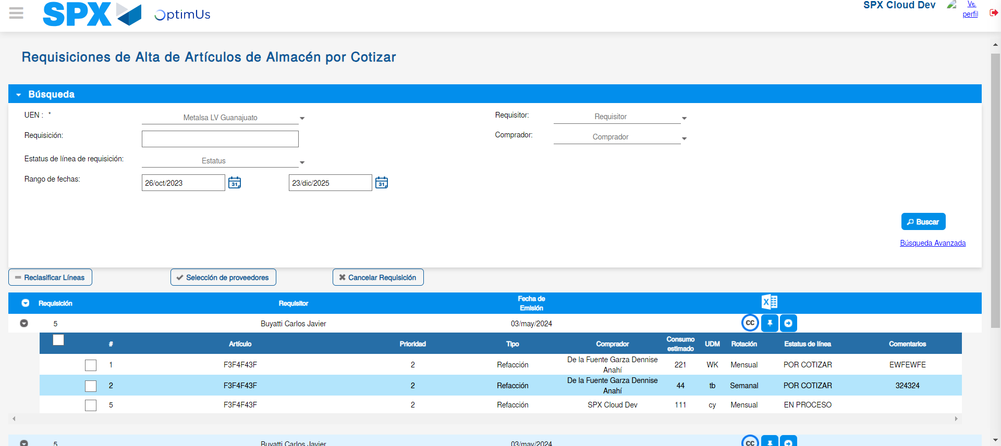Image file-name: QC_Testing-tc001_SPX_Dev5_Validar_Campos_Proceso_Nuevo_Articulos_Almacen-may. 17 2024, 02 27 40 p. m.

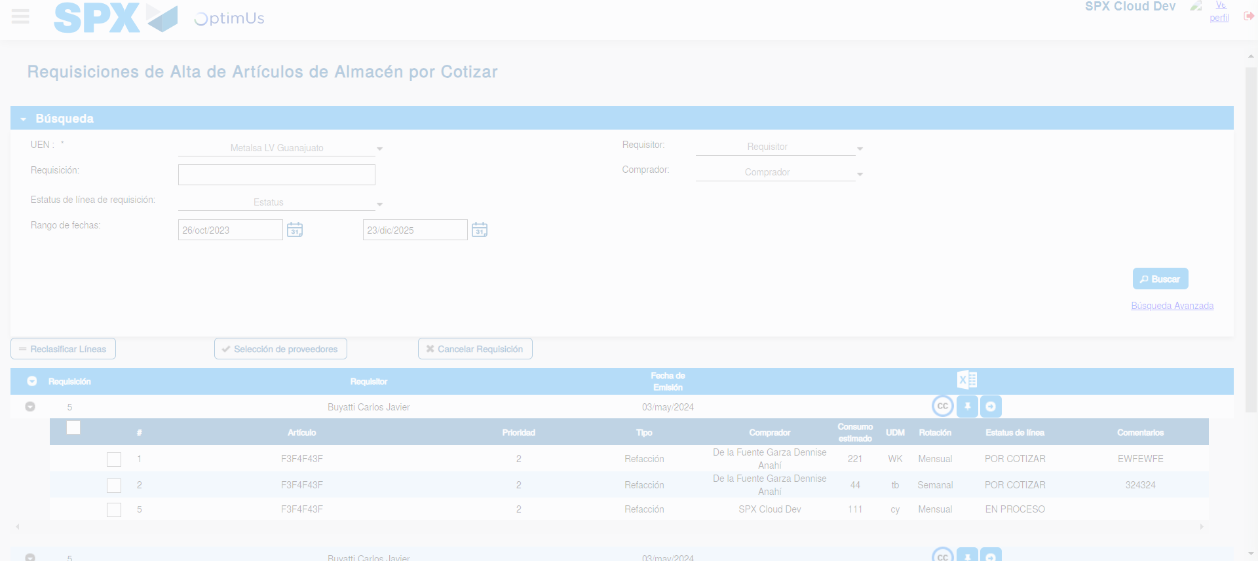Image file-name: QC_Testing-tc001_SPX_Dev5_Validar_Campos_Proceso_Nuevo_Articulos_Almacen-may. 17 2024, 02 27 41 p. m.

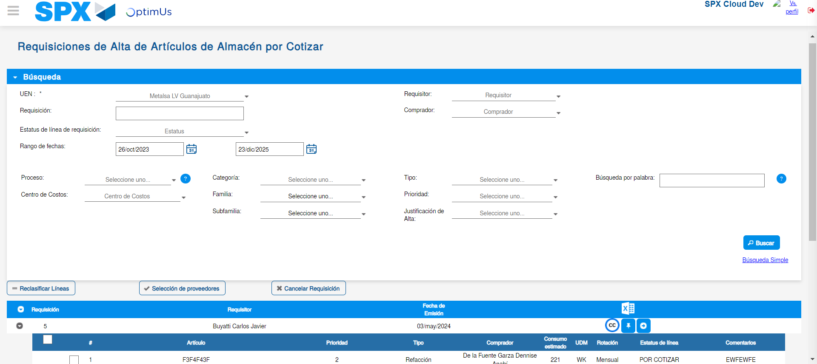Image file-name: QC_Testing-tc001_SPX_Dev5_Validar_Campos_Proceso_Nuevo_Articulos_Almacen-may. 17 2024, 02 27 43 p. m.

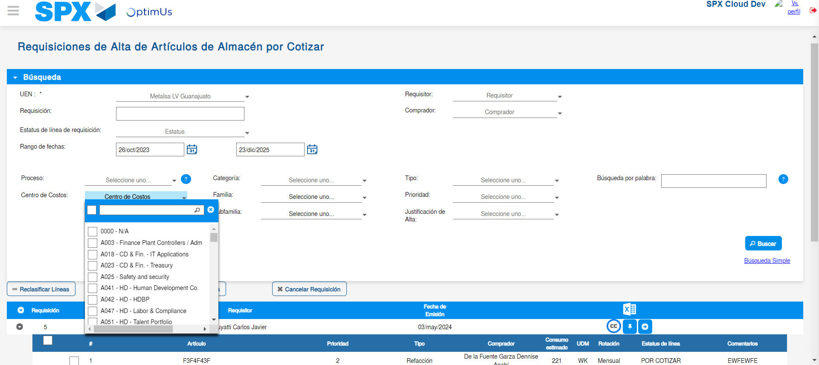Image file-name: QC_Testing-tc001_SPX_Dev5_Validar_Campos_Proceso_Nuevo_Articulos_Almacen-may. 17 2024, 02 27 44 p. m.

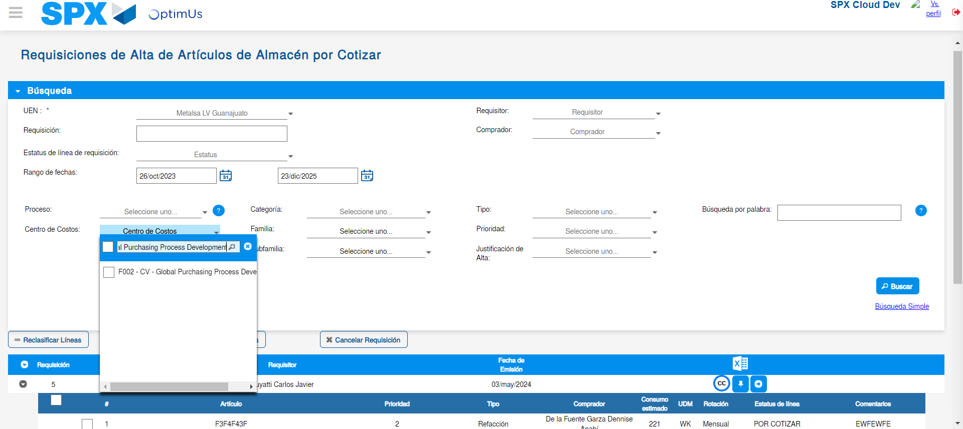Image file-name: QC_Testing-tc001_SPX_Dev5_Validar_Campos_Proceso_Nuevo_Articulos_Almacen-may. 17 2024, 02 27 45 p. m.

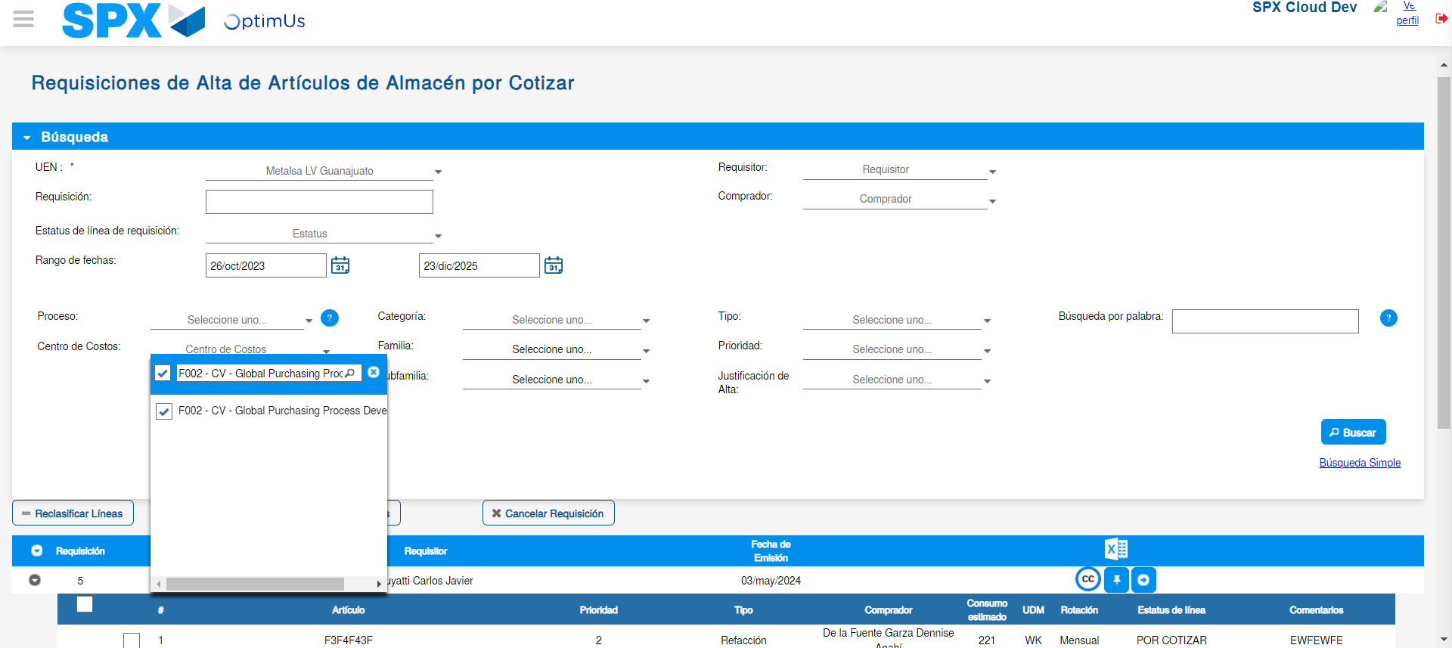Image file-name: QC_Testing-tc001_SPX_Dev5_Validar_Campos_Proceso_Nuevo_Articulos_Almacen-may. 17 2024, 02 27 49 p. m.

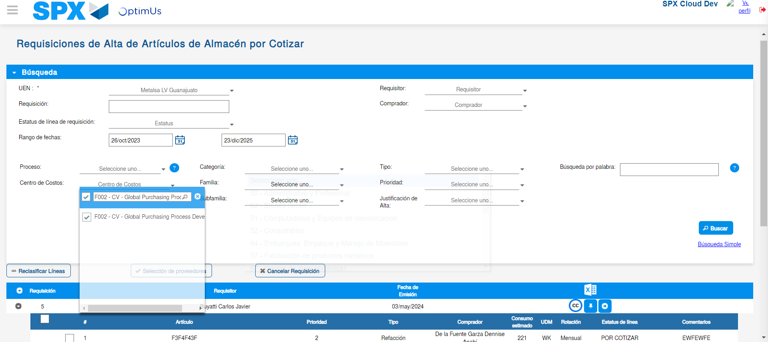Image file-name: QC_Testing-tc001_SPX_Dev5_Validar_Campos_Proceso_Nuevo_Articulos_Almacen-may. 17 2024, 02 27 52 p. m.

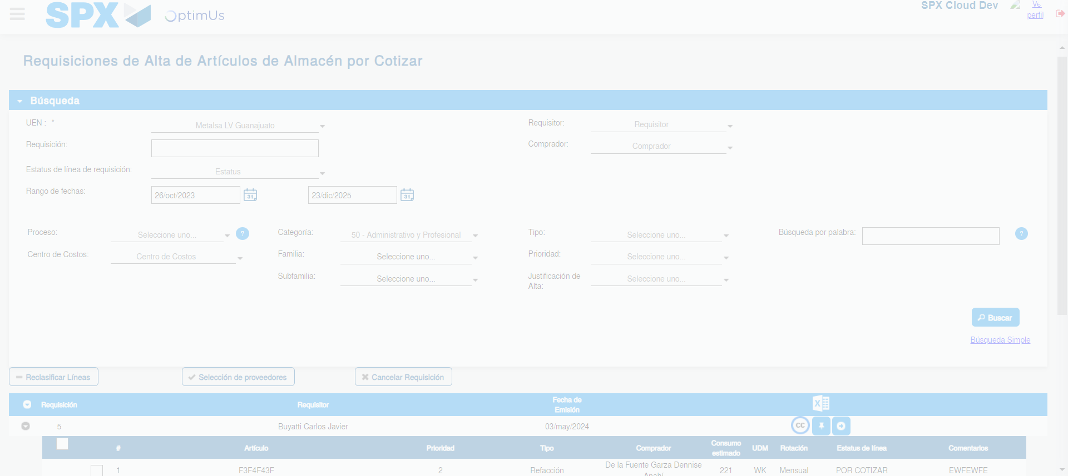Image file-name: QC_Testing-tc001_SPX_Dev5_Validar_Campos_Proceso_Nuevo_Articulos_Almacen-may. 17 2024, 02 27 53 p. m.

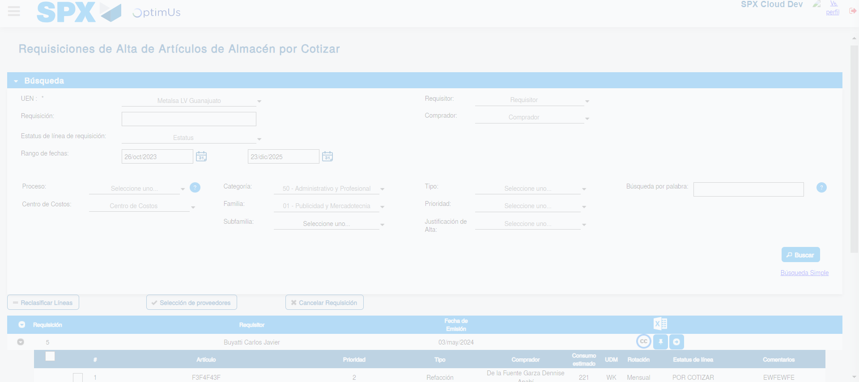Image file-name: QC_Testing-tc001_SPX_Dev5_Validar_Campos_Proceso_Nuevo_Articulos_Almacen-may. 17 2024, 02 27 56 p. m.

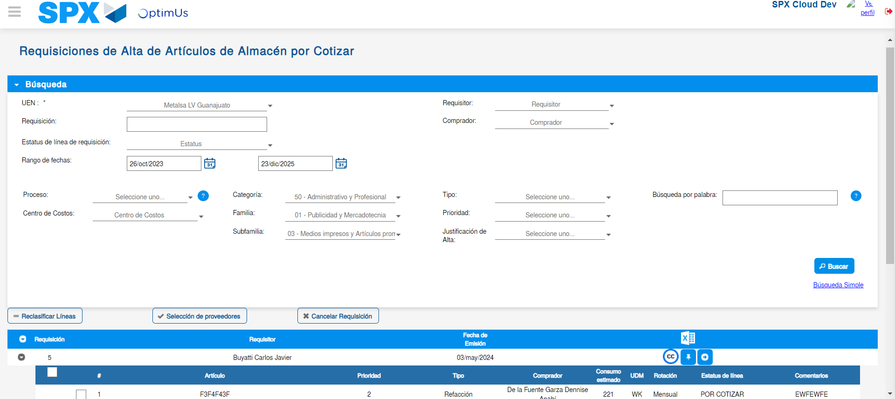Image file-name: QC_Testing-tc001_SPX_Dev5_Validar_Campos_Proceso_Nuevo_Articulos_Almacen-may. 17 2024, 02 28 00 p. m.

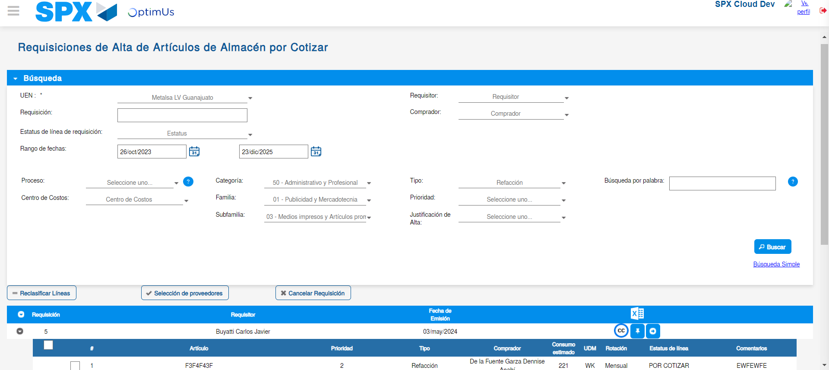Image file-name: QC_Testing-tc001_SPX_Dev5_Validar_Campos_Proceso_Nuevo_Articulos_Almacen-may. 17 2024, 02 28 04 p. m.

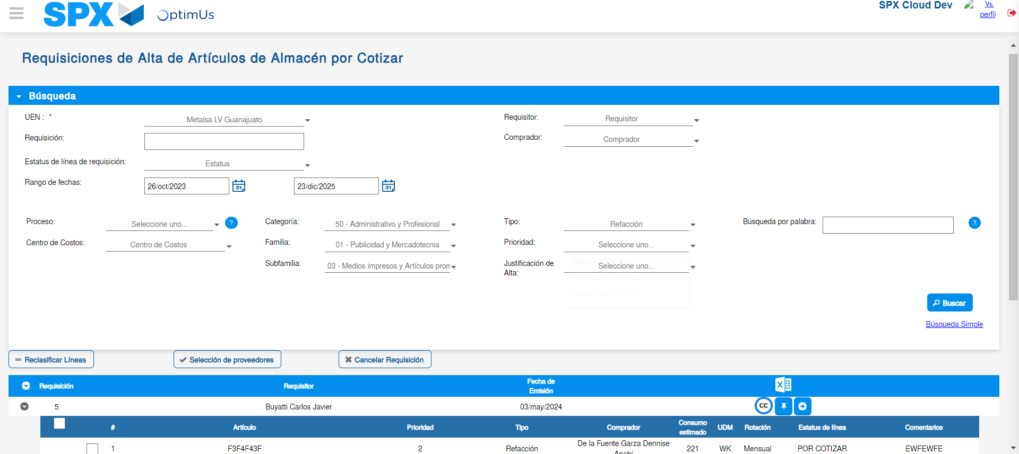Image file-name: QC_Testing-tc001_SPX_Dev5_Validar_Campos_Proceso_Nuevo_Articulos_Almacen-may. 17 2024, 02 28 07 p. m.

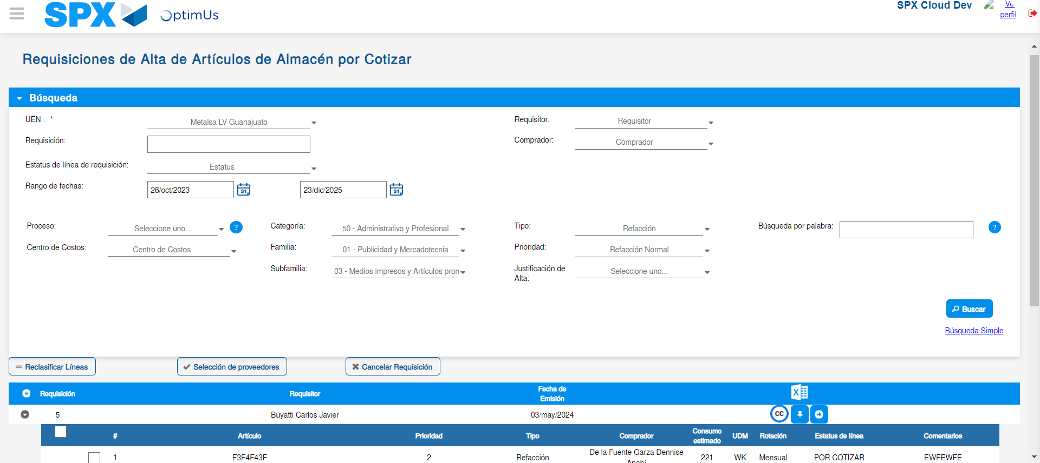Image file-name: QC_Testing-tc001_SPX_Dev5_Validar_Campos_Proceso_Nuevo_Articulos_Almacen-may. 17 2024, 02 28 08 p. m.

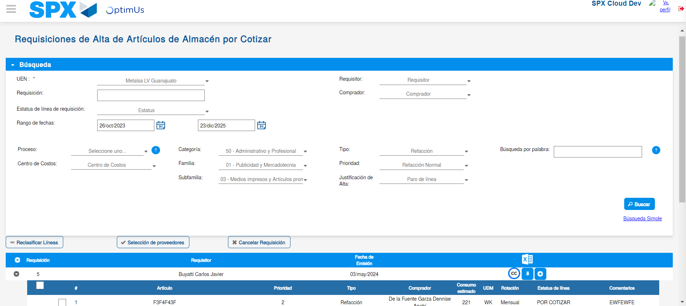Image file-name: QC_Testing-tc001_SPX_Dev5_Validar_Campos_Proceso_Nuevo_Articulos_Almacen-may. 17 2024, 02 28 11 p. m.

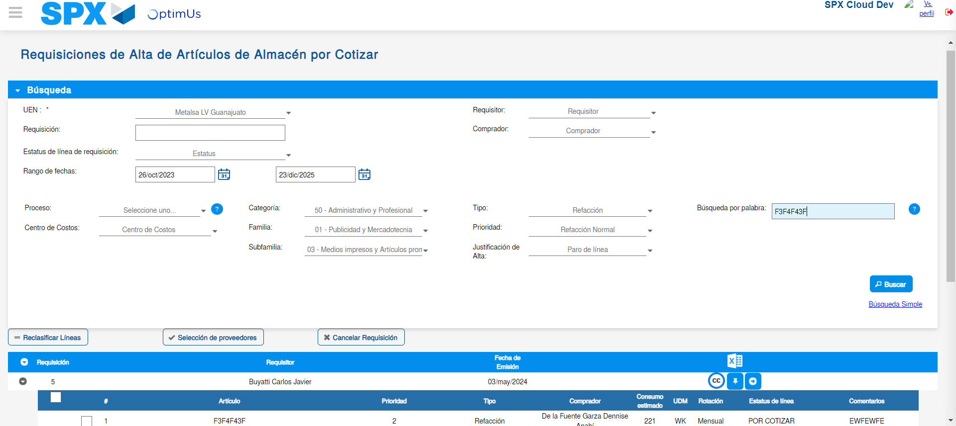Image file-name: QC_Testing-tc001_SPX_Dev5_Validar_Campos_Proceso_Nuevo_Articulos_Almacen-may. 17 2024, 02 28 15 p. m.

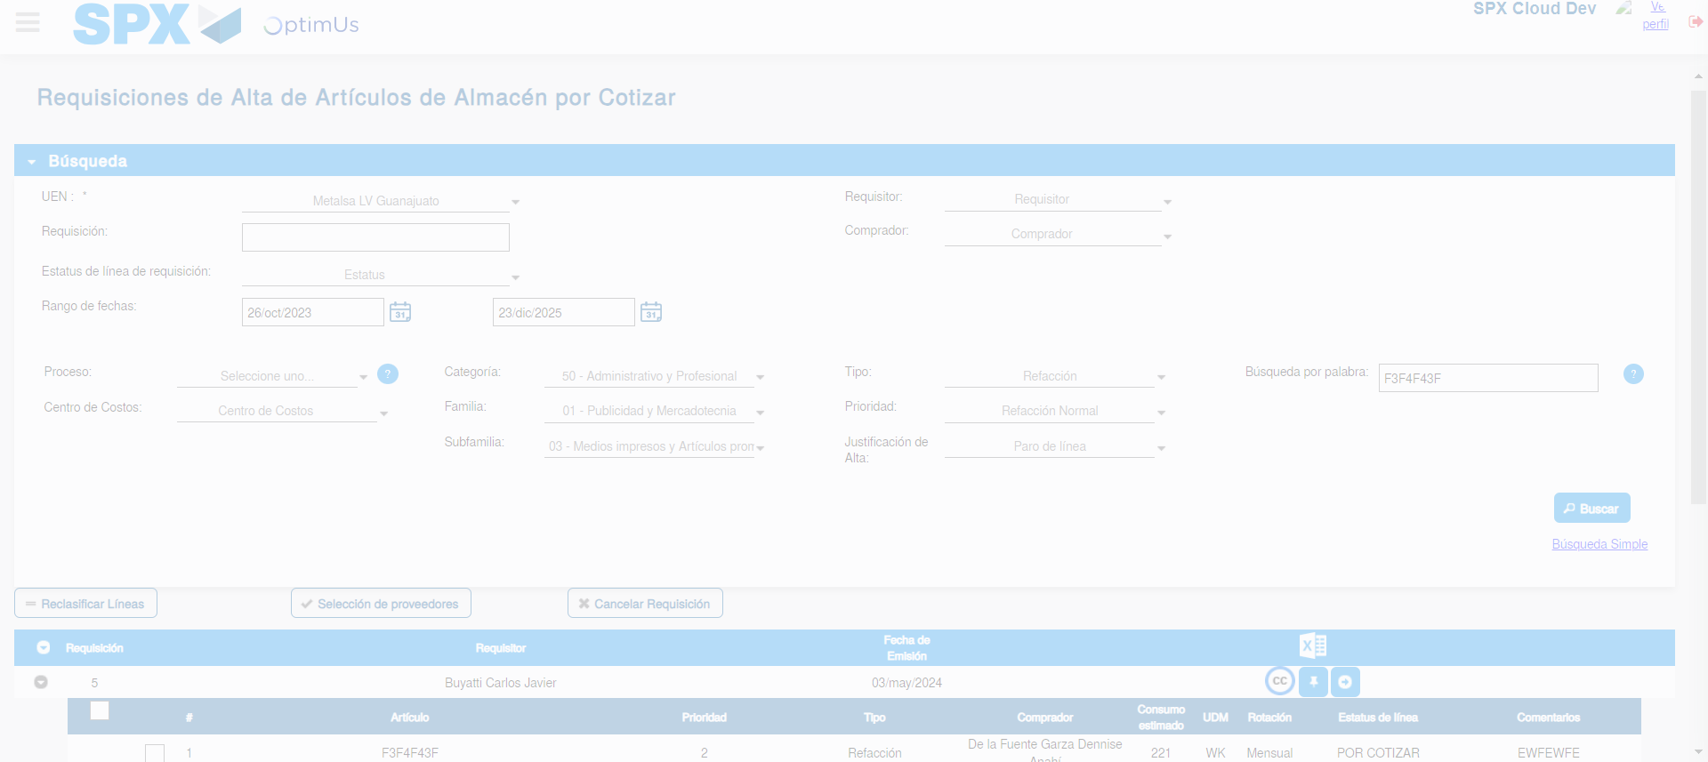Image file-name: QC_Testing-tc001_SPX_Dev5_Validar_Campos_Proceso_Nuevo_Articulos_Almacen-may. 17 2024, 02 28 18 p. m.

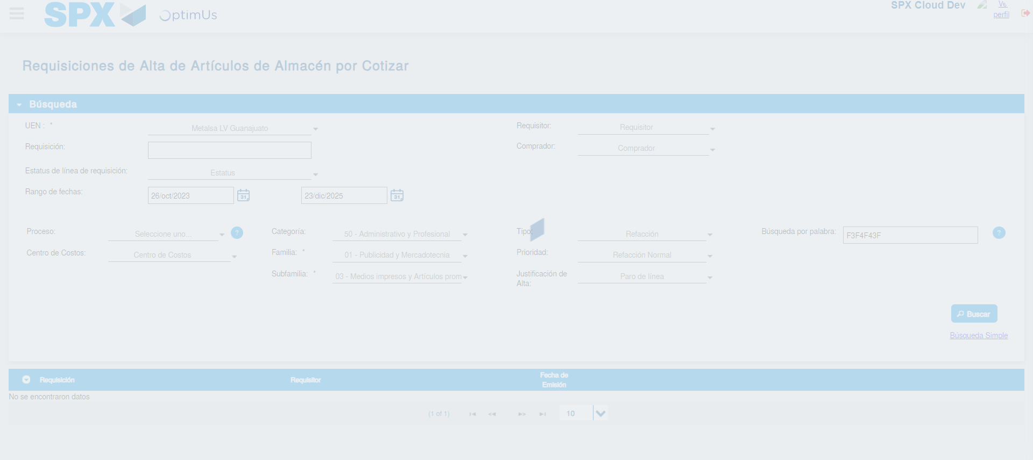Image file-name: QC_Testing-tc001_SPX_Dev5_Validar_Campos_Proceso_Nuevo_Articulos_Almacen-may. 17 2024, 02 28 22 p. m.

